**REVISED RECOMMENDED CONDITIONS Draft 9/10/2020**

**NOTICE TO APPLICANT OF DETERMINATION OF APPLICATION**

**CONSENT**

Environmental Planning and Assessment Act, 1979  
RA17/1001

**TO:**

Hawes & Swan Planning - Surry Hills

Suite 4, Level 4,

35 Buckingham Street

being the applicant(s) for **RA17/1001** relating to:

**267 Princes Hwy, MILTON - Lot 1 - DP 737576**  
**Princes Hwy, MILTON - Lot 1 - DP 780801**  
**Princes Hwy, MILTON - Lot 0 - DP U3 2224**

**APPROVED USE AND OR DEVELOPMENT:**

Housing for Seniors or people with disability development comprising:

**Phase 1** Demolition works, vegetation removal and construction of a new roundabout and associated civil infrastructure to the Princes Highway, 89 Bed Residential Care Facility (RCF), community centre including medical centre, gym, swimming pool, recreational space and restaurant, 65 Independent Living Units (ILU) in duplex and triplex forms, a large detention pond and associated civil infrastructure and landscaping.

**Phase 2** Construction of a total of 59 (ILU) in duplex and triplex forms, and associated civil infrastructure and landscaping.

**Phase 3** Construction of 7 x 3 storey residential flat buildings housing a total of 133 (ILU) with underground car parking and ancillary civil infrastructure and landscaping.

**DETERMINATION DATE:** xxxxxxxxxxxxxxxxxxxxxxxxxxxxxxxxxxxxxxxxxxxx

Pursuant to the Section 4.18 of the Act, notice is hereby given that the above application has been determined by granting consent, subject to the conditions listed below.

**CONSENT TO OPERATE FROM**:

**CONSENT TO LAPSE ON:**

*This consent is valid for five years from the date hereon.*

*In accordance with Section 4.53 of the Act, development consent for the use of the land or the erection of a building does not lapse if building, engineering or construction work relating to the building or work or the use is physically commenced on the land to which the consent applies before the lapse date.*

**DETAILS OF CONDITIONS:**

The conditions of consent and reasons for such conditions are set out as follows:

|  |  |
| --- | --- |
|  | PART  CONDITIONS OF A GENERAL NATURE, INCLUDING A DESCRIPTION OF THE PROPOSED DEVELOPMENT **(ONCE THE CONSENT IS IN OPERATION)** |
|  | ***General***  This consent relates toHousing for Seniors or people with disability development comprising:  **Phase 1** Demolition works, vegetation removal and construction of a new roundabout and associated civil infrastructure to the Princes Highway, 89 Bed Residential Care Facility (RCF), community centre including medical centre, gym, swimming pool, recreational space and restaurant, 65 Independent Living Units (ILU) in duplex and triplex forms, a large detention pond and associated civil infrastructure and landscaping.  **Phase 2** Construction of a total of 59 (ILU) in duplex and triplex forms, and associated civil infrastructure and landscaping.  **Phase 3** Construction of 7 x 3 storey residential flat buildings housing a total of 133 (ILU) with underground car parking and ancillary civil infrastructure and landscaping.  as illustrated on the plans (referenced in the table below), specifications and supporting documentation stamped with reference to this consent, as modified by the following conditions. The development must be carried out in accordance with this consent.  Where there is an inconsistency between the documents lodged with this application and the following conditions, the conditions prevail to the extent of that inconsistency.   |  |  |  |  | | --- | --- | --- | --- | | **STAMPED DOCUMENTS/PLANS** | **REF/SHEET NO.** | **PREPARED BY** | **DATED** | | Plan Cover Sheet | D18/381058 Rev P  D19/355602 | Stephen Jones Associates | 10/10/2018 | | Photomontages 01 | DA01 – A  D18/381095 | Stephen Jones Associates | 9/05/2017 | | Photomontages 02 | DA02  D18/381102 | Stephen Jones Associates | 9/05/2017 | | Photomontages 03 | DA03  D18/381104 | Stephen Jones Associates | 9/05/2017 | | Survey Plan | DA04  D18/381109 | Stephen Jones Associates | 9/05/2017 | | Site Analysis / Location Plan | DA05 G  D20/391581 | Stephen Jones Associates | 18/08/2020 | | Site Plan | DA06 G  D20/391581 | Stephen Jones Associates | 18/08/2020 | | Staging Plan | DA55 G  D20/391637 | Stephen Jones Associates | 18/08/2020 | | Site Roof Plan | DA07 G  D20/391581 | Stephen Jones Associates | 18/08/2020 | | Site Sections | DA08 F  D20/391586 | Stephen Jones Associates | 18/08/2020 | | Site Elevations | DA09 F  D20/391586 | Stephen Jones Associates | 18/08/2020 | | Site Perspectives | DA10E  D20/391586 | Stephen Jones Associates | 18/08/2020 | | Clubhouse/Medical Centre |  |  |  | | Clubhouse Site Plan | DA11 C  D20/391590 | Stephen Jones Associates | 18/08/2020 | | Medical Centre Plan | DA12 B  D20/391590 | Stephen Jones Associates | 10/09/2019 | | Clubhouse Plan | DA13 B  D20/391590 | Stephen Jones Associates | 10/09/2019 | | Clubhouse Elevations 1 | DA14 A  D20/391590 | Stephen Jones Associates | 9/05/2017 | | Clubhouse Elevations 2 | DA15 A  D20/391590 | Stephen Jones Associates | 9/05/2017 | | Clubhouse Sections | DA16 A  D20/391590 | Stephen Jones Associates | 9/05/2017 | | Clubhouse  Perspectives 1 | DA17 B  D20/391590 | Stephen Jones Associates | 10/09/2019 | | Clubhouse  Perspectives 2 | DA18 B  D20/391590 | Stephen Jones Associates | 10/09/2019 | | Residential Care Facility |  |  |  | | Residential Care Facility Site Plan | DA19  D19/354980 | Stephen Jones Associates | 10/09/2019 | | Residential Care Facility  Ground Floor Plan | DA20  D19/354982 | Stephen Jones Associates | 10/09/2019 | | Residential Care Facility  Elevations | DA21  D19/354983 | Stephen Jones Associates | 9/05/2017 | | Residential Care Facility  Sections | DA22  D19/354986 | Stephen Jones Associates | 9/05/2017 | | Residential Care Facility  Perspectives 1 | DA23  D19/354989 | Stephen Jones Associates | 10/09/2019 | | Residential Care Facility  Perspectives 2 | DA24  D19/355005 | Stephen Jones Associates | 10/09/2019 | | Duplex/Triplex Units |  |  |  | | Duplex AA - Plans &  Elevations | DA25  D19/355179 | Stephen Jones Associates | 10/09/2019 | | Duplex AA - Section &  Perspectives | DA26  D19/355182 | Stephen Jones Associates | 9/05/2017 | | Duplex BB - Plans &  Elevations | DA27  D19/355185 | Stephen Jones Associates | 10/09/2019 | | Duplex BB – Section &  Perspectives | DA28  D19/355192 | Stephen Jones Associates | 9/05/2017 | | Duplex CC – Plans &  Elevations | DA29  D19/355200 | Stephen Jones Associates | 10/09/2019 | | Duplex CC – Section &  Perspectives | DA30  D19/355205 | Stephen Jones Associates | 16/02/2017 | | Duplex DD – Plans &  Elevations | DA31  D19/355208 | Stephen Jones Associates | 10/09/2019 | | Duplex DD – Section &  Perspectives | DA32  D19/355211 | Stephen Jones Associates | 9/05/2017 | | Duplex EE – Plans &  Elevations | DA33  D19/355215 | Stephen Jones Associates | 10/09/2019 | | Duplex EE – Section &  Perspectives | DA34  D19/355224 | Stephen Jones Associates | 9/05/2017 | | Triplex EEE – Plans &  Elevations | DA35  D19/355235 | Stephen Jones Associates | 10/09/2019 | | Triplex EEE – Section &  Perspectives | DA36  D19/355240 | Stephen Jones Associates | 10/09/2019 | | Triplex DDD – Plans &  Elevations | DA56  D19/355249 | Stephen Jones Associates | 10/09/2019 | | Triplex DDD – Section &  Perspectives | DA57  D19/355254 | Stephen Jones Associates | 10/09/2019 | | Multi-storey Apartments |  |  |  | | Apartments – Typical  Basement Plan | DA37 A  D20/391610 | Stephen Jones Associates | 9/05/2017 | | Apartments – Basement Plan Alternate | DA38 B  D20/391610 | Stephen Jones Associates | 10/09/2019 | | Apartments – Typical Ground Floor Plan | DA39 A  D20/391610 | Stephen Jones Associates | 9/05/2017 | | Apartments – Typical Level 1 Floor Plan | DA40 A  D20/391610 | Stephen Jones Associates | 9/05/2017 | | Apartments – Typical Level 2 Floor Plan | DA41 A  D20/391610 | Stephen Jones Associates | 9/05/2017 | | Apartments – Typical Roof Plan | DA42 A  D20/391610 | Stephen Jones Associates | 9/05/2017 | | Apartments – Sections | DA43 D  D20/391610 | Stephen Jones Associates | 18/08/2020 | | Apartments –  Elevations 1 | DA44 D  D20/391610 | Stephen Jones Associates | 18/08/2020 | | Apartments –  Elevations 2 | DA45 D  D20/391610 | Stephen Jones Associates | 18/08/2020 | | Apartments – Perspectives 1 | DA46 C  D20/391610 | Stephen Jones Associates | 18/08/2020 | | Apartments – Perspectives 2 | DA47 C  D20/391610 | Stephen Jones Associates | 18/08/2020 | | Apartments - Basement Plan Combined | DA48 F  D20/391625 | Stephen Jones Associates | 18/08/2020 | | Apartments - Typical Floor Plan Combined | DA49 F  D20/391625 | Stephen Jones Associates | 18/08/2020 | | Apartments - Elevations | DA50 E  D20/391625 | Stephen Jones Associates | 18/08/2020 | | Apartments - Perspectives 1 | DA51 D  D20/391625 | Stephen Jones Associates | 18/08/2020 | | Apartments - Perspectives 2 | DA52 D  D20/391625 | Stephen Jones Associates | 18/08/2020 | | Apartments - Perspectives 3 | DA53 D  D20/391625 | Stephen Jones Associates | 18/08/2020 | | Finishes Schedule | DA54  D18/381687 | Stephen Jones Associates | 9/05/2017 | | Materials and Finishes | DA54  D19/355608 | Stephen Jones Associates | 9/05/2017 | | Shadow Diagrams -  Apartments Combined – 21 June | DA56 D  D20/391625 | Stephen Jones Associates | 18/08/2020 | | Landscape Plan Cover Sheet | 16-3351 F  D20/391489 | Zenith Landscape Designs | 23/07/2020 | | Landscape Plan | 16-3551 L01 to L10 Rev F  D20/391489 | Zenith Landscape Designs | 23/07/2020 | | Water Cycle Management Plan | 2019038smpA  Rev A  D19/355439 | Samana Blue Engineering P/L | 20/09/2019 | | Proposed Roundabout Concept Design Drawings | 1806-C20-C33 Issue 2  D20/391504 | Footprint Sustainable Engineering | 25/08/2019 | | Concept Civil Engineering | 2019038-C10B to C26B  D19/355577 | Samana Blue Engineering | 29/08/2019 | | Documents |  |  |  | | NATHERS Certificate | 0001476040  D17/163467 | Greenview Consulting Pty Ltd | 11/05/2017 | | NATHERS Certificate  133 units | 0001482070  D17/163479 | Greenview Consulting Pty Ltd | 13/05/2017 | | NATHERS Certificate  Apartments | 0001476040  D17/163467 | Greenview Consulting Pty Ltd | 11/05/2017 | | BASIX Certificate  Multi-dwelling Apartments | 783564  D17/163474 | Greenview Consulting Pty Ltd | 18/05/2017 | | BASIX Certificate  Multi-dwelling  Duplex/triplex | 783844M  D17/163475 | Greenview Consulting Pty Ltd | 18/05/2017 | | Statement of Environmental Effects | 18/128 V4  D19/360299 | The Planning Hub by Hawes & Swan | 17/10/2019 | | Addendum Planning Report to SEE | 20/268 V2  D20/391551 | The Planning Hub by Hawes & Swan | 28/08/2020 | | Visual Analysis Summary Report | Issue E  D18/382224 | Scape Design | 30/04/2018 | | Visual Assessment Addendum | SL110-16 Milton Seniors  D19/354839 | Scape Design | 4/10/2019 | | Flora and Fauna Assessment | 16245RP3 V6  D19/354828 | Cumberland Ecology | 20/09/2019 | | Vegetation Management Plan | 16245RP4 V6  D19/354819 | Cumberland Ecology | 20/09/2019 | | Arboricultural Impact Assessment | D3181  D18/382170 | Allied Tree Consultancy | March 2018 | | Flora and Fauna Assessment Appendix A Addendum - additional managed area within Lot 3 DP 785757, 65 Wilfords Lane | D20/88446 | Cumberland Ecology | 11/03/2020 | | Flora and Fauna Assessment Appendix A – D Addendum – Warden Road Diversion | D20/368901 | Cumberland Ecology | 8/08/2020 | | Updated Bushfire Protection Assessment | B172942 – 7  D20/151831 | Australian Bushfire Protection Planners | 28/04/2020 | | Bushfire Review Letter to support Updated Bushfire Protection Assessment | D20/151818 | Travers Bushfire & Ecology | 28/04/2020 | | Flood Analysis | 2019038smp Rev A  D19/354744 | Samana Blue Engineering P/L | 20/09/2019 | | Flood Analysis | 160529‐B  D18/382217 | Greenview Consulting P/L | 22/02/2018 | | Water Cycle Management Plan | 160529‐C  D18/382203 | Greenview Consulting P/L | 26/04/2018 | | Transport Impact Assessment | N122790 Rev D  D18/413796 | GTA Consultants | 08/06/2017 | | Addendum to TIA in response to RMS request for additional information | N122790  D18/180122 | GTA Consultants | 29/05/2018 | | Waste Management Plan | Appendix J  D17/163404 | Hawes & Swan Planning | Received 5/06/2017 | | Response to request for additional information by  Shoalhaven City Council on Design Principles, proposed Operating Model and SEPP (Housing for Seniors and People with a Disability) 2004 | D18/382191 | Judith Stubbs & Associates | 5/01/2018 | | Statement of Heritage Impact | 16/27  D17/163499 | Borst & Co Architecture | Dec 2016 | | Milton Meadows  Aboriginal Heritage Due Diligence Report | 17-0360  D18/382180 | GML Heritage P/L | 28/11/2017 | | Acoustic Assessment | REP-426816-A2  D17/163379 | Envirotech P/L | 8/12/2016 | | Traffic Noise Impact Assessment | 4215R20200625asPrincesHwyMilton(2)  D20/368805 | Koikas Acoustics Pty Ltd | 1/07/2020 | | SEPP 65 Compliance Report | D17/163271 | Stephen Jones Associates | Received 5/06/2017 | | Phase 1 (Preliminary)  Environmental Site Assessment | REF-4267-A  D17/163395 | Envirotech P/L | 7/12/2016 | | Unexpected Finds Protocol | D20/20421 | Envirotech P/L | Received 22/01/2020 | | Milton Meadows – Common Property Access Audit | D20/368796 | Sydney Access Consultants | 21/07/2020 | | Milton Meadows Access Footpath Plan | SK100  D20/368799 | Sydney Access Consultants |  | | General Terms of Approval and a Bush Fire Safety Authority under s100B of the Rural Fires Act (1997) | DA-2017-05051  D20/418936 | NSW RFS | 19/05/2020 |   ***Note:*** *Any alteration to the plans and/or documentation must be submitted for the approval of Council. Such alterations may require the lodgement of an application to amend the consent under Section 4.55 of the Act, or a fresh development application. No works, other than those approved under this consent,**must be carried out without the prior approval of Council.* |
|  | ***Prescribed Conditions***  The development must comply with relevant prescribed conditions of consent as detailed in the *Environmental Planning and Assessment Regulation 2000*. (See Division 8A.) |
|  | The approved development must not be occupied or the use must not commence until all relevant conditions of development consent have been met or unless other satisfactory arrangements have been made with Council (i.e. a security). |
|  | ***Occupation Certificate***  An Occupation Certificate must be issued by the Principal Certifier (PC) before any of the approved development can be used or occupied for each phase of the development. |
|  | |  |  |  |  |  |  |  |  |  |  |  |  |  |  |  |  |  |  |  |  |  |  |  |  |  |  |  | | --- | --- | --- | --- | --- | --- | --- | --- | --- | --- | --- | --- | --- | --- | --- | --- | --- | --- | --- | --- | --- | --- | --- | --- | --- | --- | --- | | ***Design Changes: Amended plans required***  The design of the development is to be modified as set out in the following table. Amended plans and specifications incorporating the following design amendments must be incorporated in the plans and specifications submitted with the application for a Construction Certificate:   |  |  | | --- | --- | | **Design Amendment** | **Reason for Amendment** | | 1. The concept tree protection zone plan for the Small-leaved fig submitted on 13 March 2020 to delete duplex 2, change duplex 3 to a triplex type EEE & duplex 4 to type BB and reorientate Rosebud Ave is to be incorporated into a revised site plan with an additional 1m buffer provided between the TPZ and the nearest alignment of Rosebud Ave. | To protect the long term viability of the tree. | | 1. A landscape plan must be submitted to council and Traffic for NSW (RMS) for consent prior to CC to extend and augment the existing vegetation screen located between the Princess Highway and the adjacent service lane to be accessed by the north arm of proposed roundabout. The extended vegetation screen (identified by yellow boxed area) is to be provided across the closed Warden Road Highway intersection (north) to the western boundary of 256 Princes Highway | To provide light spill protection for residents impacted by roundabout related road works | | 1. The final design of the Warden Road diversion and future roundabout to be built primarily within/adjacent to Lot 1 DP 737576 must minimise the removal of native vegetation wherever possible. To this end the landscape plan required by condition 5(b) must also include details demonstrating how the loss of native vegetation associated with highway roundabout road works has been minimised. | Although this patch of native vegetation is disturbed, it represents a stepping-stone within a fragmented landscape allowing dispersal and foraging resources for a range of native fauna species. | | 1. The Milton Meadows Ulladulla Vegetation Management Plan Cumberland Ecology (2019) must be revised to include weed control within the additional APZ area within Lot 3 DP785757, 65 Wilfords Lane as well as retained native vegetation adjacent to the diversion of Warden Road. | To ensure that the additional APZ area and vegetated buffer between the highway and the Warden Road east link to the service lane provides for ongoing weed management. | | 1. The stormwater design for highway roundabout works is to include the capture of stormwater flowing along Warden Road east of Princes Highway and to be piped via new roundabout drainage to Petty’s Creek. | To address stormwater impacts associated with aligning Warden Road with service lane on north side of highway. | | 1. The traffic island serving the south arm of proposed roundabout is to be revised to enable residents with properties on Garrads Lane to enter and leave Garrads Lane via the roundabout. | To maintain vehicular access to the highway for affected residents. | | 1. The old silo is to be identified for retention as an important link to the farming history of the locality. | To preserve local heritage. | | 1. A revised Landscape Plan must exclude the exotic Chinese Pistacio (*Pistacia chinensis*) and Chinese Elm (*Ulmus parvifolia*) species from the landscaping schedule.   The revised Landscape plan is to include a Plan of Management (POM) to ensure that the existing view planes north of 52 and 60 Winward Way are maintained for the life of the development. | They are known to produce viable seed and become invasive plants. These species must be removed from the species lists and it is recommended they be replaced with native, preferably rainforest, species.  To retain existing view planes for the residents of 52 & 60 Winwayd Way to the coast. | | 1. Phase 3 Development:   Modified plans must be submitted to show the following:   * All 1-bedroom apartments must have a minimum private open space area of 8m2. * Additional storage must be formalised & shown in basement areas | Compliance with SEPP 65 | | 1. Detailed plans demonstrating compliance with clause 34, 35, 38 and Schedule 3 of SEPP (Housing for Seniors or People with a Disability) 2004 must be provided to council for review and approval prior to the release of a Construction Certificate for each phase of the development. |  | | 1. Revised elevation/section/roof plans for the Residential Care Facility (RCF) to lower the roof pitch to a maximum of 20 degrees | To reduce the visual impact of the building on surrounding neighbours and the environment | | 1. Revised elevation/section/roof plan for the Clubhouse/Medical Centre to change the roof design from a 25 degree pitched roof to a flat skillion roof | To reduce the visual impact of the building on surrounding neighbours and the environment | | |
|  | ***Land Clearing***  The removal and/or disturbance of indigenous vegetation on the property, including canopy trees, understorey and groundcover vegetation, is restricted to that required to construct and maintain the approved development and the associated NSW Rural Fire Services specified Asset Protection Zone in accord with the documents referenced in the table to condition Number 1 of this consent. |
|  | ***Housing for Seniors and People with a Disability***  The development must comply with the access and usability standards outlined in Schedule 3 of State Environmental Planning Policy (Housing for Seniors and People with a Disability) 2004 for the life of the development. |
|  | PART  INTEGRATED DEVELOPMENT CONDITIONS |
|  | ***Natural Resource Access Regulator (NRAR) – Integrated Development Conditions***  The conditions of the General Terms of Approval issued by NRAR (Reference No. IDAS1121644, dated 18 February 2020) are included as conditions of this consent. Refer Appendix B |
|  | ***NSW Rural Fire Service (RFS) – Integrated Development Conditions***  The conditions of the General Terms of Approval issued by the RFS (Reference No. DA-2017-05051, dated 19 May 2020) must be implemented in their entirety. Refer Appendix C |
|  | PARTCONDITIONS THAT MUST BE COMPLIED WITH BEFORE WORK CAN COMMENCE |
|  | ***Principal Certifier, Construction Certificate and Notice of Commencement***  The following must be undertaken prior to the commencement of any physical activity:   * 1. A Principal Certifier (PC) must be appointed. For subdivision works in existing public roads, only Council can be appointed as the PC;   2. A Construction Certificate for any building works must be obtained from either Council or an accredited certifier before civil works of any kind (internal or external) can commence;   3. A Subdivision Works Certificate must be obtained from either Council or an accredited certifier prior to any physical activity authorised to be carried out in connection with a subdivision under the conditions of a development consent for the subdivision of land   4. Notice must be given to Council at least two (2) days prior to the commencement of any works;   5. Council must be advised in writing of the name and 24hr contact number of the designated person/company nominated by the developer or their agent to be responsible for construction of all engineering works including erosion and sediment control measures and their maintenance; and   6. Any clearing of vegetation approved under this consent is not permitted unless:      1. The erosion and sediment control measures required by this consent have been implemented and inspected by Council;      2. Evidence of an application for a Construction Certificate is provided to Council; and      3. The clearing is carried out in accordance with the relevant conditions of this consent and the approved Waste Minimisation and Management Plans. |
|  | ***Community Engagement Strategy***  Prior to the development of detailed plans for the roundabout and associated infrastructure, the applicant must implement a Community Engagement Strategy to pursue genuine consultation with affected landowners to the satisfaction of Council and RMS. |
|  | ***Shoalhaven Water***  All conditions listed on the Shoalhaven Water Development Application Notice must be complied with and accepted by Shoalhaven Water prior to the commencement of demolition works.  For further information and clarification regarding the above please contact Shoalhaven Water’s Development Unit on (02) 4429 3111.  Refer to **Appendix A** for Shoalhaven Water Development Notice |
|  | ***Aboriginal Heritage Impact***  A full Aboriginal heritage assessment is to be prepared prior to any other ground  disturbance works taking place, including:   1. formal Aboriginal consultation, in accordance with the OEH consultation guidelines *Aboriginal cultural heritage consultation requirements for proponents, 2010* 2. preliminary assessment and preparation of an Archaeological Research Design (ARD) for archaeological test excavation under the Code of Practice 3. geomorphological assessment of the study area 4. formal field survey accompanied by members from the Aboriginal community 5. archaeological test excavation, under Department of Environment Climate Change and Water (DECCW, now the OEH), Code of Practice for Archaeological Investigation of Aboriginal Objects in New South Wales 6. preparation of an Archaeological Technical Report (ATR) which conforms to the Code of Practice contextualisation of potential discovered sites within the intangible values of the cultural landscape through Aboriginal community consultation, in accordance with the Australia ICOMOS Burra Charter, 2013   If Aboriginal objects or features identified during the test excavation indicate that the  proposed works will harm Aboriginal sites, an Aboriginal Cultural Heritage Assessment will  be required that conforms to the Aboriginal Cultural Heritage Consultation Requirements for  Proponents.  If no artefacts are found during the test excavation an addendum report summarising results,  and Aboriginal community consultation undertaken, is to be completed.  Should Aboriginal objects be identified during test excavation, a whole-of-site AHIP will be required under Section 90 of the National Parkes & Wildlife Act. |
|  | ***Road Infrastructure***   1. Central Ave (Road 1) must be created initially as an internal road but built to a public road standard. The road is neither to    1. be dedicated to Council as public road; nor    2. connected with Windward Way, until such time as Windward Way has been upgraded to a sealed road standard. 2. Prior to completion of such upgrade of Windward Way, an entrance treatment, such as a clear delineating signage, will be required on Central Ave (Road 1) within the property boundary, immediately south of the junction with Warden Road West (Road 3). 3. Prior to completion of such upgrade of Windward Way, a permanent 1.4m high vehicle and pedestrian barrier fence is to be installed for the full frontage of the property with Winward Way with a minimum return of 10 m into the site where intersecting with neighbouring properties. The design of the pedestrian/vehicular barrier fence must incorporate the following features: 4. Comply with the design requirements of Transport for NSW - RMS standard Drawing R0800-15 Pedestrian Fence Type 1 - Verge https://www.rms.nsw.gov.au/business-industry/partners-suppliers/documents/standard-drawings/r0800-15.pdf 5. Anti-climb design 6. Permeable (see through) 7. Hot dip galvanised steel powder coated black 8. Vehicle Gates to match general fence arrangement and finish and are to be provided with lockable drop bolts with gate posts 4200mm C/C 9. The barrier fence gates are to be key locked closed at all times with the exception for emergency vehicles access. 10. Upon completion of Windward Way, connection to Slaughterhouse Road shall be closed. Central Ave (Road 1), including the land for the full width of road reserve shall be dedicated and transferred to Council. All private signages & delineations must be removed from the road reserve before land transfer. Connection to Windward Way shall be opened to public traffic (both road and pedestrian traffic) and the road connection must be to standard, suitable for heavy vehicle through traffic to Windward Way. |
|  | ***Roads & Maritime Services (RMS)***  Prior to the commencing works within the road reserve, the developer must:   1. Obtain Section 138 consent under the Roads Act, 1993 for the works associated with the WAD.   ***Note -*** RMS will be exercising its powers under Section 64 of the Roads Act, 1993 to become the roads authority for works associated with the WAD and therefore responsible for issuing the Section 138 consent for those specific works.   1. Prepare, and obtain RMS and Council acceptance to, a plan which details the land to be dedicated as public road (around the Princes Highway and the connection through to Windward Way), generally in accordance with Attachment 1 and Attachment 2.   ***Note*** *- for this condition Attachment 1 refers to the proposed roundabout concept design drawings 1806-C20 to C33 Issue 2 (council Trim reference D20/391504) prepared by Footprint Sustainable Engineering dated, 25/08/2019.*  ***Note*** *- for this condition Attachment 2 is the proposed Winward Way Road closure plan Drawing Number 1806-SK04 Issue 1 (council Trim reference D20/29889) prepared by Footprint Sustainable Engineering dated, 26/02/2019.*   1. Develop and implement a community information strategy in relation to the works, in consultation with, and to the satisfaction of RMS. 2. Apply for, and obtain a Road Occupancy Licence (ROL) from the RMS Traffic Operations Unit (TOU) prior to commencing roadworks on a State Road or any other works that impact a travel lane of a State Road or impact the operation of traffic signals on any road.   ***Notes –***  *For information on the ROL process and to lodge an ROL application, please visit*  *<https://myrta.com/oplinc2/pages/security/oplincLogin.jsf>*  *The applicant will need to create an account (this may take a few days to register), prior to submitting the ROL application. The applicant must submit the ROL application 10 business days prior to commencing work. It should be noted that receiving an approval for the ROL within this 10 business day period is dependent upon RMS receiving an accurate and compliant TMP.*  *The application will require a Traffic Management Plan (TMP) to be prepared by a person who is certified to prepare Traffic Control Plans. Should the TMP require a reduction of the speed limit, a Speed Zone Authorisation will also be required from the TOU.*  *An approved ROL does not constitute an approval to commence works until an*  *authorisation letter for the works has been issued by RMS Project Manager.* |
|  | ***Design Standards***  Engineering design plans and specifications for the work referred to in this consent are to be submitted for approval.   1. Details of internal civil works must be submitted to nominated accredited certifier (Private Certifier or Council) for approval. 2. Details of all proposed works in the road reserve must be submitted and approved by Council. 3. All civil works are to be in accordance with Council’s Engineering Design Specifications and Development Construction Specifications current at the time of construction unless otherwise specified in this consent. |
|  | ***Road Design Standards***   1. Concrete integral kerb and gutter with either a minimum 30mm thick 10mm asphaltic concrete on a primer seal or 2 coat bitumen seal with 14mm & 7mm aggregate surfaced shoulder (to match the existing seal) and associated drainage must be designed across the frontage of the proposed new lot(s).    * 1. The kerb and gutter must have a standard upright profile.      2. The alignment and widths will be in accordance with the submitted Concept Services Plan by Samana Blue Engineering Drawing No 2019038 – C13B Dated 29-0819.      3. The kerb and gutter must have a minimum grade of 0.5%      4. The road shoulder pavement must be designed in accordance with Council’s Engineering Design Specifications section D2.04.      5. Subsoil drainage is to be provided behind the kerb line where an outlet to existing underground drainage (or other alternative suitable to Council) is available. Subsoil drainage is to be placed on the high side of the road or both sides if the cross-fall is neutral.      6. Where roadway widening (shoulder construction) is not required, the thickness of the pavement for the new kerb and gutter maybe designed using an adopted CBR of 3.0. If a higher CBR value is used, it must be determined by geotechnical testing in accordance with Council’s Engineering Design Specification. 2. Standard concrete gutter layback and footpath crossings must be designed at the driveway entrances in accordance with Council’s Standard Drawings Plan Nos. 5104-07, 2026-05 and 2026-09 or 10 (Engineering Design Specification). 3. Speed control devices, warning and regulatory signage will require referral to the Shoalhaven Traffic Committee for acceptance. Six (6) to eight (8) weeks should be allowed for this process, acceptance and approval. 4. A 2m metres wide concrete footpath must be designed for the full length of Central Ave frontage of the development. Details are to be shown on the engineering design plans and must incorporate the following: 5. Footpath levels must comply with a 3% cross fall from the boundary to top of kerb. 6. Perambulator gutter crossing kerb ramps must be provided at intersections in accordance with AS 1428.1-2009 Design for Access and Mobility section 10.7 Figure 23/24. |
|  | ***Structural Design***  Detailed design ‘where required’ of the following works must be certified by an NPER-III registered practising engineer and submitted for approval by Council’s Development Engineer or Delegate.   1. Major drainage structures, including pre-cast concrete culverts, headwalls, wing walls and stormwater pits / structures that require steel reinforcement. 2. Retaining walls greater than 0.6 metre in height 3. Other structural design (e.g. safety barrier/fencing for culverts over 1 metre to invert).   **Note:**  *A NPER-III registered practising engineer will be required to certify that construction of the above structures has been completed in accordance with the approved plans prior to the release of the occupation certificate.* |
|  | ***Stormwater Drainage Design***   1. Major and minor drainage systems must be designed by a qualified practising engineer in accordance with Council’s Engineering Design Specifications section D5 (Stormwater Drainage Design) and DCP 2014 – Chapter G2: Sustainable Stormwater Management and Erosion/Sediment Control. The minor and major systems must be designed for 20% AEP for residential areas and have consideration for the 1% AEP rainfall events respectively. 2. Detailed design of permanent stormwater quality improvement devices and major trunk drainage must be certified by a civil or environmental engineer who has current NPER-III registration or who can demonstrate the appropriateness of the proposed design for the site. 3. Any table drains and culverts under the Central Ave roadway or within the public road and or access are to be designed:    * 1. For a minimum 20% AEP rain event.      2. To withstand the pressure of the maximum AEP stored upstream before the culvert/roadway is overtopped.      3. To resist scour and erosion within the table drains and the roadway/driveway caused by overtopping of any culvert.   Where culverts are 1m high or greater (roadway to invert) they are to be provided with guard fence in accordance with Australian Standards. |
|  | ***On-Site Detention***  On-site detention storage for stormwater runoff from the site must be provided such that the discharge from the site for design storm events up to and including the 100 year average recurrence interval does not exceed the pre-developed conditions. Details must be submitted to Council or an accredited certifier for approval prior to the issue a Construction Certificate. All flow discharging from on-site detention is to be via gravity flow to an approved discharge location. Automatic pump out systems from on-site detention will not be allowed.   1. The developer must provide details of scour protection at the outlet of the on-site detention basin, in accordance with SCC Engineering Design Specification, to Council or an accredited certifier for approval. 2. The on-site detention structure must be designed to incorporate lockable access for maintenance and a suitably graded invert to prevent ponding. 3. The on-site detention structure must be designed to withstand a T44 load as defined in Austroad’s Bridge Design Manual. |
|  | Carpark Design   1. Any car parking must be designed in accordance with A.S. 2890 Parking Facilities. 2. The internal driveway and car parking areas must be designed for Light and or Heavy vehicular loadings depending on the usage. The pavement construction minimum standard as per below:    * 1. With a flexible compacted pavement minimum thickness of 200mm, surfaced with 30mm of AC10 asphaltic concrete on a primer seal or two coat bitumen seal using 14mm and 7mm aggregate. or      2. To a concrete standard.      3. Access in and out of the development will be required in a forward direction generally in accordance with the turning movements as per A.S. 2890.1 for the 99th % vehicle or in accordance with A.S. 2890.2 for the largest vehicle requiring access to the development.      4. Any car park blind aisles shall be equal to the width of six 90-degree spaces plus 1m, unless provision is made for car to turn around at the end and exit in a forward’s direction. Refer to A.S. 2890.1. |
|  | ***Builders’ Toilet***  Before commencing building operations, a builder’s water closet accommodation must be provided to Council’s satisfaction.  A chemical toilet may be used on the site or alternatively the site may be provided with temporary closet accommodation connected to Council’s sewer where sewer is available and operational. Under no circumstances will pit toilets or similar be accepted by Council. |
|  | ***Existing Services/Damage to Public Assets (Dilapidation Report)***  Prior to the commencement of any work(s) associated with this development, the person benefitting from this consent must:   * 1. Check that the proposed works are not affected by any Council, electricity, telecommunications, gas or other services. All services, existing and proposed, above or below ground are to be shown accurately on the engineering plans including longitudinal sections with clearances to proposed infrastructure clearly labelled. Any required alterations to services as a consequence of undertaking works under this consent or any repair to services will be at the expense of the person benefitting from this consent; and   2. Undertake a site inspection and document any evidence of damage to the public assets prior to commencement of work. Any damage to the adjacent kerbs, gutters, footpaths (formed or unformed), walkways (formed or unformed), carriageway, reserves and the like, that occurs during development works must be repaired by the person benefitting from this consent. Failure to adequately identify existing damage will result in all damage detected by Council after completion of the building work being repaired at the expense of the person benefitting from this consent. A copy of the inspection documentation is to be submitted to Council prior to the commencement of works.   A copy of the inspection documentation is to be submitted to Council prior to the commencement of works. |
|  | ***Works within the Road Reserve***  Prior to undertaking any works within an existing road reserve other than in the Princes Highway corridor, the contractor must obtain the consent of Council under section 138 of the *Roads Act, 1993* and have a set of council approved plans and the letter of approval as per the development consent conditions. The following details must be submitted to Council to obtain the section138 consent:   1. Traffic Control Plan (TCP) to provide protection for those within and adjacent to the work site, including the vehicular and pedestrian public. The TCP must comply with the current RMS’s manual Traffic Control at Work Sites. Warning and protective devices must comply with the provisions of Australian Standard *AS 1742.3 – 2002 Traffic Control Devices for Works on Roads*. The plan must be prepared, signed and certified by a person holding the appropriate RMS accreditation, a copy of which is to be submitted with the plan. 2. Insurance details. 3. Name and contact information of the person/company appointed to supervise the construction. 4. Should the contractor want a single section 138 approval to cover works additional to road, drainage and site regrading (e.g. water supply, sewerage, landscaping, etc), details of such works should be forwarded to the designer of the Traffic Control Plan. Copies of the layout plans and work method statements of these additional works are to be submitted to the Development Manager in conjunction with the section 138 application for road and drainage works. 5. Where the Traffic Control/Management Plan requires a reduction of the speed limit, a ‘Direction to Restrict’ must be obtained from the RMS - Traffic Operations Unit for RMS roads or Council for other roads and submitted with the section 138 application. |
|  | ***Erosion and Sediment Control***   * 1. A Soil and Water Management Plan (SWMP) and accompanying specifications for the construction phase of the works, prepared by a suitably qualified and experienced person and based on the Landcom manual - “Soils and Construction, Managing Urban Stormwater, Vol 1, 4th Edition, March 2004”, must be lodged with the nominated Certifier for works within the proposed lot and Council for works in the road reserve for approval. The erosion and sediment measures must be maintained for the life of the construction period and until runoff catchments are stabilised.   2. Any table drains constructed or realigned are to comply with the following:      1. Table drains must not have a depth of flow higher than the bottom of the road pavement.      2. Table drains with grades less than 5% must be shaped to a uniform dish cross section placed with 75-100mm of topsoil, track machine rolled, fertilised and grass seeded with suitable native species.      3. Table drains with grades 5 to 10% must be treated similarly to those having less than 5% grade but with the addition of a layer of Jutemaster TM, Fire Mulch or equivalent product over the topsoil.      4. Table drains with grades greater than 10% must be uniformly shaped and lined with concrete, rock and cement grout or spraycrete or similar approved treatment. The road bitumen seal for grades ≥12% is to be widened to the edge of the lining. |
|  | Construction Management Plan (Traffic & Parking)  Details of the proposed method of dealing with construction traffic are to be submitted to Council for approval by the Council’s Development Engineer or Delegate. The details must include but are not limited to the following.   1. Stabilised site construction access location. 2. Proposed haulage routes for delivery of materials to the site and spoil disposal from the site. 3. Estimated timing of construction works in the form of a Gant chart or similar. 4. Parking arrangements for construction employees and contractors. 5. Proposed maintenance of the haulage routes and the name of the person responsible for such maintenance. The approved haulage route may require upgrading and or maintenance prior to commencement of any work and maintenance during the construction period for public safety. |
|  | Roads & Maritime Services (RMS)  Prior to the issuing of the Construction Certificate, the developer must:   1. Enter into a Works Authorisation Deed (WAD) with the RMS for all works on the Princes Highway.   ***Notes:***   * *A WAD is a legally binding contract between RMS and the developer, authorising the* * *developer to undertake works on a State road and/or install traffic signals.* * *To progress the WAD, the developer needs to email a copy of the conditions of development consent to development.southern@rms.nsw.gov.au.* * *All roadworks and traffic control facilities must be undertaken by a pre-qualified contractor. A copy of pre-qualified contractors can be found on the RMS website at:*   *<http://www.rta.nsw.gov.au/doingbusinesswithus/tenderscontracts/prequalifiedcontractors.htm>*   * *Any new services or modifications to existing services associated with this development application that involve works on, over or under the Princes Highway (as defined the area from kerb to kerb) must be incorporated into, and managed under, the Works Authorisation Deed for the project. Note: It is the developer’s responsibility to identify these works to RMS project manager.* * *More information on WADs can be found at:*   *[www.rms.nsw.gov.au/documents/projects/factsheet-development-process.pdf](http://www.rms.nsw.gov.au/documents/projects/factsheet-development-process.pdf)* |
|  | Engineering Design Approval – works in Road Reserve other than Princes Highway  Engineering design plans for civil works within the road reserve must be submitted to Council for approval prior to the issue of a Construction Certificate for building works. All work must be carried out in accordance with the approved plans.  Plan checking and inspection fees will be required to be paid for the works required within the road reserve as per councils standard fees and charges. |
|  | Inspection of Existing Assets  The developer or his agent must undertake a site inspection and document any evidence of damage to the public assets prior to commencement of work. A copy of the inspection documentation is to be provided to Council prior to the commencement of works. Failure to adequately identify existing damage will result in all damage detected by Council after completion of the work being repaired at the developer’s expense. |
|  | Earthworks   1. Documentation from the supplier that certifies that imported fill material is not contaminated based on analyses of the material is to be provided to Council. Sampling and analysis of the imported fill material must be conducted in accordance with the EPA Sampling Design Guidelines. 2. Details of fill storage, disposal and materials haulage routes to and from the site must be submitted to Council for approval. All surplus excavated material must be taken to an approved landfill site. |
|  | ***Pre-Clearing and Clearing Surveys***   1. Pre-clearing surveys are to be undertaken by a suitably qualified ecologist. Pre-clearing surveys must include clear demarcation of key habitat features including hollow bearing trees, fallen logs, bush rock and wombat burrows. 2. Prior to the commencement of any clearing works the drip-line (outer edge of the leaf canopy) surrounding trees to be retained, including the Tree Protection Zone of the mature *Ficus obliqua* (Small-leaf Fig) as shown on the Tree Protection Zone Plan, must be clearly identified and protected with temporary barrier fencing to prevent mechanical damage of the tree trunk, mechanical disturbance to roots, or soil build-up around the base of the tree during and after clearing works *(refer to AS 4970; Protection of trees on development sites, 2009).* Shoalhaven City Council must inspect and certify tree protection measures are in place before any work on site can commence (an inspection fee may apply). 3. Prior to the commencement of any clearing works the extent of clearing as shown on the approved plans must be accurately surveyed / measured and marked on the ground with temporary barrier fencing or similar visible material to aid in the selection of trees to be retained. Temporary fencing must remain in place until all works are completed. Fencing must not encroach on existing riparian vegetation. Shoalhaven City Council must inspect and certify in writing that tree protection measures are in place before any work on site can commence (an inspection fee may apply). 4. Prior to the commencement of works, a Soil and Water Management Plan (SWMP) and accompanying specifications for the construction phase of the works, prepared by a suitably qualified and experienced person and based on the Landcom manual - Soils and Construction, Managing Urban Stormwater, Vol 1, 4th Edition, March 2004”, must be submitted to the PCA (for works within the development lot) and Council (for works within the road reserve) for approval. 5. Prior to the commencement of any works, the approved erosion and sediment control measures must be implemented by the contractor, and inspected and approved by the PCA prior to the commencement of any other site works. The erosion and sediment measures must be maintained for the life of the construction period and until runoff catchments are stabilised. |
|  | ***Exclusion Zone***  The outer edge of the Milton Ulladulla Subtropical Rainforest Endangered Community and Threatened Species Retention Zone as shown in Figure 3 of the Milton Meadows Ulladulla Vegetation Management Plan Cumberland Ecology (2019) must be clearly marked with parra webbing or similar and managed as an exclusion zone for the duration of the construction period. No vehicle access, storage of materials, tools, machinery, waste, disposal of liquid waste or washing of tools or equipment is to occur within these areas. |
|  | ***Wildlife Protection***   1. Clearing must be undertaken in the following two stage process under the supervision of a suitably qualified ecologist: 2. The initial phase must involve clearing around identified habitat features and leaving features overnight. 3. The second stage will involve clearing of habitat features left overnight following inspection. 4. All clearing works are to be supervised on site by a suitably qualified environmental consultant. 5. All vegetation must be inspected for wildlife prior to clearing and works must cease until wildlife has moved on or is removed by a qualified ecologist or wildlife handler if required. 6. Prior to the commencement of any clearing works, 18 fauna boxes must be installed in consultation with the suitably qualified environmental consultant supervising the clearing. Fauna boxes must conform as a minimum with the specifications indicated in “Birds Australia Information Sheet No.5: Nestboxes for Natives” <http://www.birdlife.org.au/images/uploads/education_sheets/INFO-Nestbox-technical.pdf> . The size of nest boxes must reflect the size of hollows removed. Shoalhaven City Council must inspect and certify in writing the nest boxes are in place prior to works commencing (an inspection fee may apply). 7. Management of wombat burrows within the development footprint must include: 8. Avoid burrows wherever possible 9. For burrows that cannot be avoided a qualified ecologist must supervise the pre-clearance survey and relocation of wombats including;  * Set up a motion detector camera on each burrow to monitor use and confirm activity. * Block passage to any inactive burrows. * For active burrows, install a gate at the entrances (frame with a one way exit and no re-entry) with follow up camera footage to ensure wombat has not re-entered the burrow.  1. Wildlife protection measures must include: 2. All vegetation to be removed must be inspected for wildlife prior to removal 3. Farm sheds or other structures proposed for demolition that may provide habitat for microbats and other native wildlife and must be inspected prior to removal 4. Works must cease until any wildlife present has relocated 5. All vehicles and mechanical plant must be inspected for wildlife prior to operation 6. All trenches must be inspected for wildlife prior to backfilling 7. Any injured wildlife must be referred to Wildlife Rescue South Coast 0418 427 214 |
|  | ***Endeavour Energy Requirements***  Approval must be obtained from Endeavour Energy for the provision of electrical infrastructure and moving of powerlines underground prior to commencement of works.  Refer to **Appendix D** for detailed Endeavour Energy Advisory Notes |
|  | ***Tree Protection***   1. The alignment and any associated impacts from the construction of Rosebud Avenue must be outside the Tree Protection Zone (TPZ) for the mature *Ficus obliqua* (Small-leaf Fig) as shown on the Tree Protection Zone Plan. Detailed plans for the road must show the road alignment outside the TPZ). 2. A permanent fence such as a chain wire or post and rail, or similar, is required around the Tree Protection Zone (TPZ) for the mature *Ficus obliqua* (Small-leaf Fig) as shown on the Tree Protection Zone Plan to delineate the boundary for specific ongoing landscape management requirements of this area. The specifications for this fence must be shown on detailed plans prior to the issue of a construction certificate. 3. Where engineering works are proposed near treed or vegetated areas the applicant must provide dimensioned engineering plans that show all areas of vegetation / trees to be retained surrounded by temporary protective fencing. No plans should be approved unless these protective measures are shown and contain a note stating the fencing is to be installed prior to works and must remain in place until all works are completed. No services (water sewer etc) are to be approved within areas of vegetation to be retained or under the “drip line” of trees to be retained. |
|  | ***Flood & Water Sensitive Urban Design***   1. All stormwater treatment devices and Onsite Detention facilities must be in private ownership 2. The Stormwater Layout (Drg 2019038 – C16 B), proposed SW360 Bio-retention Enlarged Plan (Drg 2019038 – C20 B) and Concept Bio-retention Section (Drg 2019038 – C23 B) shows the proposed Filterra bioretention device online and with the inlet pipe entering the base of the bioretention device. Stormwater runoff needs to enter from the surface to allow treatment as water flows downwards through the bioretention device. The proposed bioretention device configuration therefore needs to be revised. 3. The outlet pipe from the below ground stormwater detention tanks preferably needs to be above the 1% AEP peak flood level or have a suitable non-return valve installed to ensure floodwater cannot back up into these tanks. 4. For all proprietary stormwater treatment devices such as the proposed Ocean Protect Jellyfish, the applicant needs to provide documentation from the supplier showing that the proposed device has been appropriately sized for the contributing catchment. This is important to ensure the water quality targets in Chapter G2 of the DCP can be met and the device can be maintained in a cost effective manner by the site owner. 5. The large ornamental / water quality pond must include approximately 300mm of extended detention storage between a restricted discharge outlet and overflow weir in accordance with D7.18 of Councils Engineering Design Specifications. Given that this pond seems to be oversized for a water quality objective, a smaller detention depth would be acceptable. The stormwater detention storage should ideally be provided above this water quality storage. 6. The Erosion & Sediment Control Plan (Drg 2019038 – C25 B) identifies that the detention pond / basin is to be constructed first as a temporary sediment control device and all stormwater runoff is to be directed to the pond with scour protection overflow weirs. This approach is supported however note that this pond cannot be used as an ornamental pond / water quality pond until all contributing surfaces have been stabilised with either impervious or established grassed surfaces and all accumulated sediment generated from construction phase sediment-laden stormwater runoff has been removed. |
|  | ***Sign – Supervisor Contact Details***  A sign must be erected in a prominent position on any site where any building, subdivision or demolition work is being carried out:   * 1. Showing the name, address and telephone number of the PC for the work;   2. Showing the name of the principal contractor (if any) for any building work and a telephone number on which that person may be contacted outside working hours; and   3. Stating that unauthorised entry to the site is prohibited.   Any such sign is to be maintained while the work is being carried out. |
|  | ***Public Safety and Protection of Public Property***  The site/area where works are being undertaken is to be fenced in accordance with Safework NSW requirements prior to the commencement of works, suitable for keeping members of the public and unauthorised people out. |
|  | Asbestos – Notification of Neighbours  Fourteen (14) days prior to the commencement of any demolition works involving asbestos, all immediate neighbours must be notified in writing of the intention to carry out asbestos demolition works. Copies of these written notifications should be retained and submitted to Council. |
|  | Asbestos – Statement  No later than seven (7) days prior to the demolition of any building or structure, a written statement must be submitted to Council indicating whether the building or structure contains asbestos or material containing asbestos and, if so, the following must also be submitted:   * 1. A hazardous substances audit report prepared by a competent and appropriately qualified person in compliance with Australian Standard AS2601 - 2001: The demolition of structures; and   2. A hazardous substances management plan prepared by a competent and appropriately qualified person in compliance with Australian Standard AS2601 - 2001: The demolition of structures. |
|  | PART (PHASE 1)  CONDITIONS THAT MUST BE COMPLIED WITH BEFORE A CONSTRUCTION CERTIFICATE CAN BE ISSUED FOR PHASE 1 |
|  | ***Housing for Seniors and People with a Disability***  Prior to the issue of a construction certificate all development must comply with the access and usability standards outlined in Schedule 3 of State Environmental Planning Policy (Housing for Seniors and People with a Disability) 2004 for the development. Details of compliance are to be submitted to the Accredited Certifier for approval. |
|  | ***Shoalhaven Water***  Prior to the issue of a Construction Certificate, all conditions listed on the Shoalhaven Water Development Application Notice under the heading “Prior to the Issue of a Construction Certificate” must be complied with and accepted by Shoalhaven Water. The authority issuing the Construction Certificate for the development must obtain written approval from Shoalhaven Water allowing a Construction Certificate to be issued.  ***Note****: Relevant details, including monetary**contributions (where applicable) under the Water Management Act 2000, are given on the attached Notice issued by Shoalhaven Water.*  *For further information and clarification regarding the above please contact Shoalhaven Water’s Development Unit on (02) 4429 3111.*  Refer to **Appendix A** for Shoalhaven Water Development Notice |
|  | ***Road Design, Access and Driveway Locations***   1. Prior to the issue of a construction certificate, a plan must be submitted to Council that demonstrates how the proposed access method to Warden Road (east of the Princes Highway) has been informed by consultation with affected residents. 2. Driveways locations along the service lane to the east of the site are to be shown on the plans. 3. Construction level plans are to be provided to Council ensuring the following: 4. Kerb and gutter provided on the service lane east of the Princes Highway to the proposed intersection with Warden Road. 5. Use of an alternative method of restriction at the intersection of Garrads Lane and the Princes Highway. *(The current proposal is bollards or large rocks; it is the recommendation of the EDU that large trees be used in the area instead to enhance the aesthetic of the respective roads)* 6. Garrads Lane is to be widened to 6.0m trafficable width *(lip of kerb to lip of kerb)* to comply with Council’s DCP 7. Kerb and Gutter must be provisioned on Garrads Lane 8. Warden Road West (Road 03) *(Within the road reserve)* is to be widened to 6.0m to comply with Council’s DCP 9. Kerb and gutter must be provisioned on Warden Road West (Road 03) and the road is to be sealed in accordance with Council’s DCP 10. The intersection of Warden Road West (Road 03) and Garrads Lane is to be realigned to fit wholly within the road reserve of Warden Road 11. Sight lines are to be provided at each intersection 12. Provision of swept path plans at the intersection of Warden Road West (Road 03) and Central Ave (Road 01) 13. Swept path plans are to show the largest trafficable vehicle and must show offset clearances in accordance with Austroads guidelines. 14. Offset clearances in accordance with Austroads guidelines are to be shown for the swept path plans at the intersection of Princes Highway and Central Ave (Road 01) 15. C3 edge line marking is to be provisioned within the No Stopping zones as shown on the provided plans. *(C3 edge line marking can be used in lieu of the proposed R5-400 (BW) signage)* 16. Advanced roundabout warning signage is to be provisioned on the construction level plans 17. Provision of all access paths and associated infrastructure detailed within the Milton Meadows Access Footpath Plan, Drawing Number SK100 (D20/391498) prepared by Sydney Access Consultants dated, 21/07/2020 and the amended Landscape Plans, Drawing Number 16-3351 sheets L01-L10 Rev F (D20/391489) dated 23/07/2020. |
|  | ***Line Markings & Signs***  Prior to the issue of a construction certificate, details of any line markings, regulatory signs, traffic facilities or speed controls/speed controlling devices (internal or external) shall be submitted to Council for referral to the Shoalhaven Traffic Committee and subsequent recommendation to Council. Six to eight weeks should be allowed for this process, plus additional time if amendments to the plans are required.  ***NOTE:*** *In this instance, following the submission of information by the applicant Road 01 is to be taken as Central Avenue and Road 03 is the road reserve of Warden Road West.* |
|  | ***Road Design***   1. Design of the proposed mobility scooter paths for the development (Milton Meadows Access Footpath Plan, Drawing Number SK100 (D20/391498) prepared by Sydney Access Consultants dated, 21/07/2020 and the amended Landscape Plans, Drawing Number 16-3351 sheets L01-L10 Rev F (D20/391489) dated 23/07/2020) must be compliant with the State Environmental Planning Policy (Housing for Seniors or People with a Disability) 2004, in particular Part 2 (26)(2)(c), construction details are to be submitted to Council prior to issue of a construction certificate   Should the applicant require public transport operators to enter the proposed development site, Central Avenue and any adjoining roads to be used as a loop road are to be designed to Council’s DCP and Austroads Guidelines including an appropriate LATM strategy for the development.   1. All on-site parking is to be in accordance with AS2890. Details of the parking in site, including the proposed parking adjacent to the Residential care facility is to be provided to Council for referral to the Shoalhaven Traffic Committee. 2. The applicant is to ensure that speed control devices within the road reserve are installed with respect to an LATM strategy that has created a speed environment in accordance with Council’s DCP. 3. Internal roads are to be designed to Council’s DCP and Austroads Guidelines. 4. Construction level details of the internal roads are to be provided to Council prior to the issue of a construction certificate. |
|  | ***Local Government Act 1993 – Section 68 Approval***  Approval for water, sewer and drainage works is required to be obtained under Section 68 of the Local Government Act prior to the issue of a Construction Certificate. |
|  | Waste Minimisation and Management  A detailed Waste Minimisation and Management Plan (WMMP) must be prepared in accordance with Chapter G7, Shoalhaven Development Control Plan 2014. The WMMP must be approved by Council or an accredited certifier prior to the issue of a Construction Certificate.  ***Note****: “Waste” has the same meaning as the definition of “Waste” in the Protection of the Environment Operations Act 1997.* |
|  | ***Contributions for Additional Services and/or Facilities***  This development will generate a need for additional services and/or facilities as described in Council's *Contributions Plan 2019*, as itemised in the following table:  **Phase 1**  Residential Care facility   |  |  |  |  |  |  |  | | --- | --- | --- | --- | --- | --- | --- | | Project | Description | Rate | Qty | Total | GST | GST Incl | | CW FIRE 2001 | Citywide Fire & Emergency services | $138.13 | 34.6 | $4,779.30 | $0.00 | $4,779.30 | | CW FIRE 2002 | Shoalhaven Fire Control Centre | $202.07 | 34.6 | $6,991.62 | $0.00 | $6,991.62 | | CW MGMT 3001 | Contributions Management & Administration | $574.39 | 34.6 | $1,177.09 | $0.00 | $1,177.09 | | Sub Total: | | | | | | $12,948.01 | | GST Total: | | | | | | $0.00 | | Estimate Total: | | | | | | $12,948.01 |   Contribution rates are adjusted annual on 1st July in accordance with the indexation formula indicated in the Contributions Plan (currently the implicit price deflator) and the total contribution levied will be adjusted accordingly at the time of payment. (i.e. contributions are calculated on the rate applicable at the date of payment, not the date of development consent.)  A total contribution, currently assessed as per the table above or as indexed in future years must be paid to Council before the issue of a Construction Certificate.  Contributions Plan 2019 can be accessed on Councils website [www.shoalhaven.nsw.gov.au](http://www.shoalhaven.nsw.gov.au) or may be inspected on the public access computers at the libraries and the Council Administrative Offices, Bridge Road, Nowra and Deering Street, Ulladulla. |
|  | ***Contributions for Additional Services and/or Facilities***  This development will generate a need for additional services and/or facilities as described in Council's *Contributions Plan 2019*, as itemised in the following table:  **Phase 1**  Clubhouse/Medical Centre   |  |  |  |  |  |  |  | | --- | --- | --- | --- | --- | --- | --- | | Project | Description | Rate | Qty | Total | GST | GST Incl | | CW FIRE 2001 | Citywide Fire & Emergency services | $138.13 | 2.04 | $281.79 | $0.00 | $281.79 | | CW FIRE 2002 | Shoalhaven Fire Control Centre | $202.07 | 2.04 | $412.22 | $0.00 | $412.22 | | CW MGMT 3001 | Contributions Management & Administration | $574.39 | 2.04 | $69.40 | $0.00 | $69.40 | | Sub Total: | | | | | | $763.41 | | GST Total: | | | | | | $0.00 | | Estimate Total: | | | | | | $763.41 |   Contribution rates are adjusted annual on 1st July in accordance with the indexation formula indicated in the Contributions Plan (currently the implicit price deflator) and the total contribution levied will be adjusted accordingly at the time of payment. (i.e. contributions are calculated on the rate applicable at the date of payment, not the date of development consent.)  A total contribution, currently assessed as per the table above or as indexed in future years must be paid to Council before the issue of a Construction Certificate.  *Contributions Plan 2019* can be accessed on Councils website [www.shoalhaven.nsw.gov.au](http://www.shoalhaven.nsw.gov.au) or may be inspected on the public access computers at the libraries and the Council Administrative Offices, Bridge Road, Nowra and Deering Street, Ulladulla. |
|  | ***Contributions for Additional Services and/or Facilities***  This development will generate a need for additional services and/or facilities as described in Council's *Contributions Plan 2019*, as itemised in the following table:  **Phase 1**  Duplex/Triplex   |  |  |  |  |  |  |  | | --- | --- | --- | --- | --- | --- | --- | | Project | Description | Rate | Qty | Total | GST | GST Incl | | 05 AREC 0005 | Planning Area 5 - Active recreation facility upgrades various locations | $1,045.12 | 43.2 | $45,149.18 | $0.00 | $45,149.18 | | 05 CFAC 2010 | Southern Shoalhaven Branch Library | $525.90 | 43.2 | $22,718.88 | $0.00 | $22,718.88 | | CW AREC 0005 | Shoalhaven Community and Recreational Precinct SCaRP Cambewarra Road Bomaderry | $929.11 | 43.2 | $40,137.55 | $0.00 | $40,137.55 | | CW CFAC 0007 | Shoalhaven Regional Gallery | $72.29 | 43.2 | $3,122.93 | $0.00 | $3,122.93 | | CW CFAC 2002 | Shoalhaven Multi Purpose Cultural & Convention Centre | $650.76 | 43.2 | $28,112.83 | $0.00 | $28,112.83 | | CW CFAC 2006 | Shoalhaven City Library Extensions, Berry Street, Nowra | $867.56 | 43.2 | $37,478.59 | $0.00 | $37,478.59 | | CW FIRE 2001 | Citywide Fire & Emergency services | $138.13 | 43.2 | $5,967.22 | $0.00 | $5,967.22 | | CW FIRE 2002 | Shoalhaven Fire Control Centre | $202.07 | 43.2 | $8,729.42 | $0.00 | $8,729.42 | | CW MGMT 3001 | Contributions Management & Administration | $574.39 | 43.2 | $19,141.66 | $0.00 | $19,141.66 | | Sub Total: | | | | | | $210,558.27 | | GST Total: | | | | | | $0.00 | | Estimate Total: | | | | | | $210,558.27 |   Contribution rates are adjusted annual on 1st July in accordance with the indexation formula indicated in the Contributions Plan (currently the implicit price deflator) and the total contribution levied will be adjusted accordingly at the time of payment. (i.e. contributions are calculated on the rate applicable at the date of payment, not the date of development consent.)  A total contribution, currently assessed as per the table above or as indexed in future years must be paid to Council before the issue of a Construction Certificate.  *Contributions Plan 2019* can be accessed on Councils website [www.shoalhaven.nsw.gov.au](http://www.shoalhaven.nsw.gov.au) or may be inspected on the public access computers at the libraries and the Council Administrative Offices, Bridge Road, Nowra and Deering Street, Ulladulla. |
|  | PART (PHASE 2)  CONDITIONS THAT MUST BE COMPLIED WITH BEFORE A CONSTRUCTION CERTIFICATE CAN BE ISSUED FOR PHASE 2 |
|  | ***Contributions for Additional Services and/or Facilities***  This development will generate a need for additional services and/or facilities as described in Council's *Contributions Plan 2019*, as itemised in the following table:  Duplex/Triplex   |  |  |  |  |  |  |  | | --- | --- | --- | --- | --- | --- | --- | | Project | Description | Rate | Qty | Total | GST | GST Incl | | 05 AREC 0005 | Planning Area 5 - Active recreation facility upgrades various locations | $1,045.12 | 40.6 | $42,431.87 | $0.00 | $42,431.87 | | 05 CFAC 2010 | Southern Shoalhaven Branch Library | $525.90 | 40.6 | $21,351.54 | $0.00 | $21,351.54 | | CW AREC 0005 | Shoalhaven Community and Recreational Precinct SCaRP Cambewarra Road Bomaderry | $929.11 | 40.6 | $37,721.87 | $0.00 | $37,721.87 | | CW CFAC 0007 | Shoalhaven Regional Gallery | $72.29 | 40.6 | $2,934.97 | $0.00 | $2,934.97 | | CW CFAC 2002 | Shoalhaven Multi Purpose Cultural & Convention Centre | $650.76 | 40.6 | $26,420.86 | $0.00 | $26,420.86 | | CW CFAC 2006 | Shoalhaven City Library Extensions, Berry Street, Nowra | $867.56 | 40.6 | $35,222.94 | $0.00 | $35,222.94 | | CW FIRE 2001 | Citywide Fire & Emergency services | $138.13 | 40.6 | $5,608.08 | $0.00 | $5,608.08 | | CW FIRE 2002 | Shoalhaven Fire Control Centre | $202.07 | 40.6 | $8,204.04 | $0.00 | $8,204.04 | | CW MGMT 3001 | Contributions Management & Administration | $574.39 | 40.6 | $17,989.62 | $0.00 | $17,989.62 | | Sub Total: | | | | | | $197,885.78 | | GST Total: | | | | | | $0.00 | | Estimate Total: | | | | | | $197,885.78 |   Contribution rates are adjusted annual on 1st July in accordance with the indexation formula indicated in the Contributions Plan (currently the implicit price deflator) and the total contribution levied will be adjusted accordingly at the time of payment. (i.e. contributions are calculated on the rate applicable at the date of payment, not the date of development consent.)  A total contribution, currently assessed as per the table above or as indexed in future years must be paid to Council before the issue of a Construction Certificate.  *Contributions Plan 2019* can be accessed on Councils website [www.shoalhaven.nsw.gov.au](http://www.shoalhaven.nsw.gov.au) or may be inspected on the public access computers at the libraries and the Council Administrative Offices, Bridge Road, Nowra and Deering Street, Ulladulla. |
|  | ***Shoalhaven Water***  Prior to the issue of a Construction Certificate, all conditions listed on the Shoalhaven Water Development Application Notice under the heading “Prior to the Issue of a Construction Certificate” must be complied with and accepted by Shoalhaven Water. The authority issuing the Construction Certificate for the development must obtain written approval from Shoalhaven Water allowing a Construction Certificate to be issued.  ***Note****: Relevant details, including monetary**contributions (where applicable) under the Water Management Act 2000, are given on the attached Notice issued by Shoalhaven Water.*  *For further information and clarification regarding the above please contact Shoalhaven Water’s Development Unit on (02) 4429 3111.*  Refer to **Appendix A** for Shoalhaven Water Development Notice |
|  | ***Waste Storage Room Construction.***  A design certificate and detailed plans are to accompany any Construction Certificate application which demonstrate that the waste storage room has been designed to be constructed in accordance with the Waste Management Guide and including the following requirements:   1. The floor is to be constructed of concrete at least 75mm thick and adequately graded to drain to a Sydney Water approved drainage fitting; 2. The floor must be finished so that it is non-slip and has a smooth and even surface covered at all intersections; 3. The ceilings and walls must be finished with smooth faced non-absorbent material capable of being cleaned; 4. The room is to be provided with artificial light controllable within the room and adequate ventilation; 5. The room is to be provided with an adequate supply of hot and cold water mixed through a centralised mixing valve with hose cock. |
|  | PART (PHASE 3)  **CONDITIONS THAT MUST BE COMPLIED WITH BEFORE A CONSTRUCTION CERTIFICATE CAN BE ISSUED** |
|  | ***Contributions for Additional Services and/or Facilities***  This development will generate a need for additional services and/or facilities as described in Council's *Contributions Plan 2019*, as itemised in the following table:  **Phase 3**  Apartments   |  |  |  |  |  |  |  | | --- | --- | --- | --- | --- | --- | --- | | Project | Description | Rate | Qty | Total | GST | GST Incl | | 05 AREC 0005 | Planning Area 5 - Active recreation facility upgrades various locations | $1,045.12 | 88.2 | $92,179.58 | $0.00 | $92,179.58 | | 05 CFAC 2010 | Southern Shoalhaven Branch Library | $525.90 | 88.2 | $46,384.38 | $0.00 | $46,384.38 | | CW AREC 0005 | Shoalhaven Community and Recreational Precinct SCaRP Cambewarra Road Bomaderry | $929.11 | 88.2 | $81,947.50 | $0.00 | $81,947.50 | | CW CFAC 0007 | Shoalhaven Regional Gallery | $72.29 | 88.2 | $6,375.98 | $0.00 | $6,375.98 | | CW CFAC 2002 | Shoalhaven Multi Purpose Cultural & Convention Centre | $650.76 | 88.2 | $57,397.03 | $0.00 | $57,397.03 | | CW CFAC 2006 | Shoalhaven City Library Extensions, Berry Street, Nowra | $867.56 | 88.2 | $76,518.79 | $0.00 | $76,518.79 | | CW FIRE 2001 | Citywide Fire & Emergency services | $138.13 | 88.2 | $12,183.07 | $0.00 | $12,183.07 | | CW FIRE 2002 | Shoalhaven Fire Control Centre | $202.07 | 88.2 | $17,822.57 | $0.00 | $17,822.57 | | CW MGMT 3001 | Contributions Management & Administration | $574.39 | 88.2 | $39,080.89 | $0.00 | $39,080.89 | | Sub Total: | | | | | | $429,889.80 | | GST Total: | | | | | | $0.00 | | Estimate Total: | | | | | | $429,889.80 |   Contribution rates are adjusted annual on 1st July in accordance with the indexation formula indicated in the Contributions Plan (currently the implicit price deflator) and the total contribution levied will be adjusted accordingly at the time of payment. (i.e. contributions are calculated on the rate applicable at the date of payment, not the date of development consent.)  A total contribution, currently assessed as per the table above or as indexed in future years must be paid to Council before the issue of a Construction Certificate.   * *Contributions Plan 2019* can be accessed on Councils website [www.shoalhaven.nsw.gov.au](http://www.shoalhaven.nsw.gov.au) or may be inspected on the public access computers at the libraries and the Council Administrative Offices, Bridge Road, Nowra and Deering Street, Ulladulla. |
|  | ***Shoalhaven Water***  Prior to the issue of a Construction Certificate, all conditions listed on the Shoalhaven Water Development Application Notice under the heading “Prior to the Issue of a Construction Certificate” must be complied with and accepted by Shoalhaven Water. The authority issuing the Construction Certificate for the development must obtain written approval from Shoalhaven Water allowing a Construction Certificate to be issued.  ***Note****: Relevant details, including monetary**contributions (where applicable) under the Water Management Act 2000, are given on the attached Notice issued by Shoalhaven Water.*  *For further information and clarification regarding the above please contact Shoalhaven Water’s Development Unit on (02) 4429 3111.*  Refer to **Appendix A** for Shoalhaven Water Development Notice |
|  | ***Car Wash Bay***  A vehicle wash bay must be provided for residents of the development. Collection, reuse  and ultimate disposal of water used in the vehicle wash bay shall be in accordance with  Council requirements. The car wash bay shall be designed so that the following  requirements are met:   * Have an adequate parking and washing floor space. * Provide a water supply. * Minimise water use with appropriate devices (e.g., such as a gun-type nozzle which closes when released and a timer operative valve, collection and use of rainwater). * Have a water supply cut out system/fail-safe mechanisms provided to ensure that mechanical failure; drainage blockage or lack of maintenance cannot result in wastewater surcharge into the stormwater system. * Be designed to ensure that over spray, drift of water or detergent does not cause a nuisance to persons, vehicles, residences, other buildings, neighbouring properties or the environment. * Be located so that washing can occur with minimal disturbance to other residents, * Details to be submitted to the Principal Certifying Authority |
|  | ***Waste Chute Design***  Where the development incorporates a Waste Chute as part of the waste management system, a design certificate and detailed plans are to accompany any Construction Certificate application which confirms that the waste chute can be constructed to satisfy the Waste Management Guide and specifically the following requirements:   1. Chutes, service openings and charging devices are constructed of metal or a smooth faced surface which is fire resistant and of impervious material 2. Chute is cylindrical in section, vertical and without bends as it passes through the floors 3. Chutes must terminate in the waste storage room and discharge into a waste bin 4. Comply with manufactures technical specifications and operational limitations.   Where the waste management system incorporates the use of a waste chute system, contingency plan should be in place for the development to allow for the continual disposal and collection of waste if the chute cannot be operated. |
|  | ***Residential Flat Development Residential Waste Storage Area***  The waste storage area shall be roofed, screened from public view and provided with:   1. Openings, 5% of the floor area and recessed into the walls, positioned to provide cross floor ventilation OR mechanical ventilation to Council’s satisfaction; 2. An adequate water supply provided by a hose cock and hose (hot water for commercial premises) 3. The floor shall be made of an impervious surface, drained to sewer in accordance with Council requirements.   Plans and specifications for the storage room shall be submitted with the application for  the Construction Certificate. |
|  | PARTCONDITIONS RELATING TO THE APPROVED WORK AND SITEMANAGEMENT |
|  | Building Code of Australia  All building work must be carried out in accordance with the requirements of the Building Code of Australia.  ***Note:*** *This condition is prescribed under the Environmental Planning and Assessment Regulation 2000.* |
|  | ***Aboriginal Heritage Impact Permit***  Any specific conditions of an AHIP are to be adhered to. |
|  | ***Work Hours and Noise***  The following must be complied with during demolition and construction works:   1. To limit the impact of the development on adjoining owners, all demolition and construction work must be restricted to the hours of 7.00am to 6.00pm Monday to Friday and 8.00am to 3.00pm Saturdays. No work is to take place on Sundays or Public Holidays. Any proposed change to hours must be approved by Council in writing; and 2. The noise from all activities associated with any demolition works and construction of the approved development must comply with the work practices as outlined in the NSW Department of Environment & Climate Change *Interim Construction Noise Guideline*. The LA10 level measured over a period of not less than 15 minutes when the construction site is in operation must not exceed the background (LA90) noise level by more than 10dB(A) when assessed at any sensitive noise receiver. |
|  | Impact of Works on Others  The following general conditions must be adhered to;   1. Runoff currently entering the site from uphill properties must not be obstructed nor redirected from entering the site, other than by works in accordance with a plan approved by Council, to increase the quantity or concentration of surface runoff entering adjoining properties. 2. Any damage to the existing kerb & gutter, footpaths, pathways, road pavements, reserves or any other public infrastructure that occurs during development works must be repaired by the developer. Restoration must be to the satisfaction of Council. 3. Existing roads, footpaths and reserves adjacent to and nearby the site must be kept clear of soil, debris, materials and equipment except in accordance with the Traffic Control Plan or as otherwise approved in writing by Council. 4. All vehicles associated with the construction works as conditioned in this consent must not block or hinder access to or from adjoining lots or through traffic movements without traffic control in accordance with the Roads and Maritime Services Traffic Control at Worksite Manual prepared, installed and controlled by personnel holding relevant qualifications. All signage must comply with AS 1742.3. 5. All construction work is to be carried out so that at any time adjoining property owners are not deprived of an all-weather access or subjected to additional storm water runoff during the period of construction. |
|  | Earthworks  Documentation from the supplier that certifies that imported fill material is not contaminated based on analyses of the material is to be provided to Council during the works. Sampling and analysis of the imported fill material must be conducted in accordance with the EPA Sampling Design Guidelines. |
|  | ***Land Management***   1. The Milton Ulladulla Subtropical Rainforest Endangered Community, Threatened Species Retention Zone and Tree Protection Zone for the mature *Ficus obliqua* (Small-leaf Fig) must be clearly marked and maintained as an exclusion zone for the duration of the construction period. No vehicle access storage of materials, tools, machinery, waste, disposal of liquid waste or washing of tools or equipment is to occur within these areas. 2. The alignment and any associated impacts from the construction of Rosebud Avenue must be outside the Tree Protection Zone (TPZ) for the mature *Ficus obliqua* (Small-leaf Fig) as shown on the Tree Protection Zone Plan. 3. A permanent fence such as a chain wire or post and rail, or similar, is required around the Tree Protection Zone (TPZ) for the mature *Ficus obliqua* (Small-leaf Fig) as shown on the Tree Protection Zone Plan. 4. All clearing works must be supervised on site by a suitably qualified environmental consultant to minimise the risk of harm to retained vegetation, native fauna and rescue any injured fauna if required.      1. The environmental consultant must provide a written report to Shoalhaven City Council (email to Council’s Environment Officer acceptable) detailing any fauna detected as a result of the clearing works. The report is to be submitted within ten days of clearing works being undertaken. 2. Management actions monitoring and reporting as detailed in the Milton Meadows Ulladulla Vegetation Management Plan Cumberland Ecology (2019) must begin at the initiation of approved onsite works and be implemented according to the timing detailed in the schedule of works (Table 2).      1. Reporting on the restoration works must be conducted according to Section 7.1.2 of the Milton Meadows Ulladulla Vegetation Management Plan Cumberland Ecology (2019) and be submitted to Council on a six monthly basis, beginning at the initiation of onsite works. 2. Trees to be cleared must be felled into the development area carefully so as not to damage trees to be retained in or beyond the development footprint. 3. Hollow-bearing trees must be felled carefully in sections utilising a “cherry picker” or crane if necessary, to allow the rescue of native fauna. Hollow-bearing sections must be carefully lowered to the ground so as not to injure native fauna.      1. The parking of machinery and vehicles or the storing of building or landscaping materials, soil, spoil, or rubbish, within the fenced area around trees and native vegetation to be retained is prohibited. 2. Sediment erosion controls must be in place immediately following clearing and on the same day as clearing works commence. Erosion and sediment controls shall be installed in accordance with the Standard Drawing of the ‘Blue Book’ *Managing Urban Stormwater (MUS): Soils and Construction Vol.1* (Landcom 2004) and shall be maintained in good working order for the duration of works and subsequently until the site has been stabilised and the risk of erosion and sediment from the site is minimal. |
|  | ***Heritage***  Should any historical relics be unexpectedly discovered in any areas of the site, then all excavation or disturbance to the area is to stop immediately and the Heritage Council of NSW should be informed in accordance with Section 146 of the Heritage Act 1977. |
|  | Should any Aboriginal relics be unexpectedly discovered in any areas of the site, then all excavation or disturbance to the area is to stop immediately and the Office of Environment and Heritage should be informed in accordance with Section 89A of the National Parks and Wildlife Act, 1974. |
|  | ***Waste Minimisation and Management Plan***  All waste must be contained within the site during construction and then be recycled in accordance with the approved Waste Minimisation and Management Plan (WMMP) or removed to an authorised waste disposal facility. No waste must be placed in any location or in any manner that would allow it to fall, descend, blow, wash, percolate or otherwise escape from the site.  Compliance with the WMMP must be demonstrated by the retention of relevant receipts. These must be submitted to Council, upon request.  ***Note****: “Waste” has the same meaning as the definition of “Waste” in the Protection of the Environment Operations Act 1997.* |
|  | ***Waste Management Plan Environmental Requirements – Demolition & Construction***  Requirements of the approved Waste Management Plan shall be complied with during all site preparation works, demolition (if proposed) and throughout all construction works.  When implementing the Waste Management Plan the developer is to ensure:  (a) The disposal of any demolition and construction waste must be undertaken in accordance with the requirements of the Protection of Environment Operations Act 1997  (b) All waste on site is to be stored, handled and disposed of in such a manner as to not create air pollution, offensive noise or pollution of land and water as defined by the Protection of Environment Operations Act 1997  (c) Generation, storage, treatment and disposal of hazardous waste is conducted in accordance with the relevant waste legislation administered by the EPA and relevant Occupational Health and Safety legislation administered by WorkCover NSW  (d) All waste generated (including excavated materials) which cannot be reused or recycled must be transported to a facility which can lawfully accept it  (e) Records are retailed regarding the details and location of the disposal of all demolition and construction waste (including excavated material) and are to be kept on site as evidences of lawful disposal. Records are to include receipts and weighbridge dockets which verify material types and volumes, time and date of disposal and confirmation of the waste disposal facility  (f) All materials and resources that are to be stored on site during construction works are contained on the site, The provisions of the Protection of Environment Operations Act 1997 must be complied with when placing/stock piling loose material, disposal of concrete waste or activities which have potential to pollute drains and water courses  (g) The storage of waste and recycling containers must be within the boundaries of the development site at all times. Public footways and roads must not be used for the storage of any waste and must be kept clear of obstructions during all construction works. |
|  | Approved Waste Management Plan – Operational Requirements Post Construction  The approved Waste Management Plan is to be implemented throughout the ongoing use of the development.  Contracts (or agreements) with cleaners, building managers and tenants must clearly outline the waste management and collection system and must clearly identify everyone’s role and responsibility. This is to include:  (a) Responsibility for cleaning and maintaining waste storage bins and containers  (b) Responsibility for cleaning and maintaining waste storage room  (c) Responsibility for the transfer of bins to the nominated collection point  (d) Method of communication to new tenants and residents concerning the developments waste management system.  (e) Cleaning up and management of bulky waste   1. Adequate signage is to be provided and maintained on how to use the waste management system and what materials are acceptable for recycling within all waste storage areas of the development. 2. Signage is also to be provided and maintained which clearly identifies which bins (and containers) are to be used for general waste and recycling and what materials can be placed in each bin.   Where the development incorporates strata title subdivision, the by-laws are to clearly set out the management responsibilities for the developments waste and recycling system. |
|  | ***Contaminated Land - Unexpected Findings***  If unexpected contaminated soil and/or groundwater is encountered during any works; all work must cease and the situation must be promptly evaluated by an appropriately qualified and experienced environmental consultant. The contaminated soil and/or groundwater must then be managed under the supervision of the environmental consultant, in accordance with relevant NSW Environment Protection Authority (EPA) Guidelines.  If unexpected contaminated soil or groundwater is treated and/or managed onsite; the supervising environmental consultant must verify that the situation was appropriately managed in accordance with relevant NSW EPA guidelines.  The verification documentation must be provided to the satisfaction of the Principal Certifying Authority (PCA) and Shoalhaven City Council, prior to the recommencement of any works.  *Note: An appropriately qualified and experienced environmental consultant must be certified by one of the following certification schemes, or demonstrate an equivalent standard:*   * *CEnvP “Site Contamination” (SC) Specialist - by Certified Environmental Practitioner*   *‘Certified Professional Soil Scientist’ (CPSS CSAM) by Soil Science Australia (SSA)* |
|  | ***SEPP 55 – Contaminated Land requirements***   1. During asbestos removal, signs reading “Danger Asbestos Removal in Progress” measuring a minimum 400 mm must be erected in clearly visible positions near the removal works; 2. Air monitoring must be conducted by a suitable qualified person during asbestos removal and during loading out of the contaminated material. Further monitoring is required in the event of excess wind during the removal or disturbance of soil. 3. All removal works must comply with the requirements of WorkCover NSW; 4. Soil must be stripped from the footprint of all former buildings on site extending at least 1,000 mm in all directions and to a minimum depth of 50 mm; 5. Hazardous building materials and asbestos containing soils are to be safely disposed at a facility licensed to receive such waste with receipts retained for proof of safe and appropriate disposal. |
|  | Asbestos – Clearance Certificate (Friable Asbestos)  Following the removal of all friable asbestos and prior to further works being carried out on the site, a clearance certificate from an independent occupational hygienist in accordance with the National Occupational Health and Safety Commission Code of Practice for the Safe Removal of Asbestos is to be obtained and submitted to Council*.* |
|  | Asbestos – Clearance Certificate (Bonded Asbestos)  Following the removal of all bonded asbestos and prior to further works being carried out on the site, a clearance certificate from an independent competent person current WorkCover Class 2 (Restricted) Asbestos Licence in accordance with the National Occupational Health and Safety Commission Code of Practice for the Safe Removal of Asbestos is to be obtained and submitted to Council. |
|  | Asbestos – Tip Receipts  Documentary evidence in the form of tip receipts from an approved Waste Management Facility must be obtained demonstrating the appropriate disposal of the asbestos waste. Tip receipts must be provided to Council at the completion of demolition works and prior to any further works on the site. |
|  | Asbestos – Licensed Contractors  Demolition works involving the removal and disposal of asbestos cement must only be undertaken by contractors who hold a current WorkCover Asbestos Removal Licence or a current WorkCover Class 2 (Restricted) Asbestos Licence. |
|  | Demolition – Work Cover  Precautions must be taken in accordance with the requirements of the SafeWork NSW in respect of:   * 1. Protection of site workers and the public;   2. Asbestos handling and disposal where applicable. |
|  | Demolition – Adverse Effects to Adjoining Owners  Suitable measures must be taken to ensure that there is no adverse effect to occupants of adjoining buildings and the public by the generation of dust and/or noise during demolition. |
|  | Demolition  Demolition work must be carried out in accordance with *Australian Standard AS2601-2001: The Demolition of Structures*. |
|  | PART **CONDITIONS THAT MUST BE COMPLIED WITH BEFORE AN OCCUPATION CERTIFICATE CAN BE ISSUED FOR EACH PHASE** |
|  | ***Roads & Maritime Services (RMS)***  Prior to the issuing of the Occupation Certificate (interim or final), the developer must:   1. Complete the formal dedication of land as public road (around the Princes Highway and the connection through to Windward Way) to the satisfaction of RMS and Council and generally in accordance with Attachment 1 and Attachment 2. 2. Construct the proposed roundabout on the Princes Highway to the satisfaction of RMS, generally in accordance with Attachment 1, Austroads Guide to Road Design and other relevant standards.   *Notes:*   * *The pavement design and drainage design on the Princes Highway must be in accordance with Austroads/relevant standards.* * *Where required, the developer must upgrade/provide lighting in accordance with Australian Standard AS/NZS1158.* * *All works need to be completed at no cost to RMS*  1. Make the necessary local access adjustments (including the Warden Road connection to the service lane and the Garrads Lane connection to the Road 3) to the satisfaction of Council, generally in accordance with Attachment 1, Austroads Guide to Road Design and other relevant standards. 2. Physically close any redundant access points to the Princes Highway (including the Warden Road and Garrads Lane connections to the Princes Highway), generally in accordance with Attachment 1 and to the satisfaction of RMS. 3. Construct the internal central road to the satisfaction of Council from the proposed Princes Highway roundabout to within 20m of Windward Way, or as otherwise agreed to by both RMS and Council.   ***Note*** *- for this condition Attachment 1 refers to the proposed roundabout concept design drawings 1806-C20 to C33 Issue 2 (council Trim reference D20/391504) prepared by Footprint Sustainable Engineering dated, 25/08/2019.*  ***Note*** *- for this condition Attachment 2 is the proposed Winward Way Road closure plan Drawing Number 1806-SK04 Issue 1 (council Trim reference D20/29889) prepared by Footprint Sustainable Engineering dated, 26/02/2019.* |
|  | ***Registration of Restrictions on Title of Property***  Prior to the issue of an Occupation Certificate by the Principal Certifying Authority, the following must be created as restrictions-as-to-user under Section 88E of the Conveyancing Act 1919:   1. A restriction limiting the use of the 89 bed Residential Aged Care Facility and all duplex, triplex and apartment self care units in perpetuity to: 2. seniors or people who have a disability, 3. people who live within the same household with seniors or people who have a disability, 4. staff employed to assist in the administration of and provision of services to housing provided under State Environmental Planning Policy (Housing for Seniors or People with a Disability) 2004. 5. In preparing the Instrument setting out the terms of easements and restrictions affecting this land, ensure that such restrictions cannot be varied, modified or released without the consent of the Shoalhaven City Council. |
|  | ***Private Waste Collection Contract***  Prior to the issue of any Occupation Certificate, the developer is to enter into a formal agreement with a licenced private waste contractor to service the development. The contract is to ensure the removal of all waste from the development site.  Prior to entering into an agreement for a private waste collection service, the developer is to ensure that:   1. The service is functional and meets the operational needs of the development 2. The service minimises environmental nuisances including noise and other adverse impacts on the safety and amenity of residents and the public. 3. Council has been provided with indemnity against claims for loss or damage, should they take over the service at some point in the future.   A copy of the contract is to be forwarded to Council prior to the issue of any Occupation Certificate. |
|  | ***Verification of Works***   1. A certificate from a qualified practising structural engineer must be submitted to Council to certify all structural elements have been constructed in accordance with the approved plans. 2. ‘Work As Executed’ (WAE) plans certified by a consulting engineer or registered surveyor must be submitted to Council for review and records upon completion of the works. The certification must state the information shown on the plans is a true and accurate representation of the constructed works. The WAE information is to be marked in red and be provided on a copy of the Council approved plans in an electronic format. Where works are not within the tolerances specified in Council’s Development Construction Specifications, the certifying engineer / surveyor must confirm, in writing, the works still comply with the intent of the original design, specifications and relevant Australian Standards. |
|  | ***Registration of Easements / Restriction to use / Right of Carriageway***  The creation of easement for services, rights of carriageway and restrictions as to user are applicable under Section 88B of the Conveyancing Act 1919, including (but not limited to) the following:   1. Easements for stormwater drainage, services and all public services / infrastructure on private and public property. 2. Drainage Easements are to be placed over all subsurface drains, inter allotment drainage and swale drains benefitting and burdening property owners. The width of subsurface drain easements is to be a minimum of 1 metre wide, depending on the depth of pipe (refer to section D5.16 and D5.18 of Council’s Engineering Design Specifications). Maintenance of the drains is to be included in the 88B instrument. 3. An easement must be dedicated to council for all new drainage works discharging from the roundabout/highway to a suitable watercourse. 4. All stormwater from the proposed highway works & roundabout be discharged to the existing watercourse located in the proponent’s lot, and an easement be required to be dedicated to council on the proponent’s land |
|  | ***Reporting Vegetation Management Plan***  Reporting on the restoration works according to Section 7.1.2 of the Milton Meadows Ulladulla Vegetation Management Plan Cumberland Ecology (2019) must be up to date and restoration works meeting the performance criteria detailed in Table 2 of the Plan prior to the issue of an occupation certificate.  Reporting from the environmental consultant (email to Council’s Environment Officer acceptable) detailing any fauna detected as a result of the clearing works must be submitted. |
|  | ***Landscape Plan***  Completion of landscaping in accordance with the approved Landscape Plan prior to issue of an Interim or Final Occupation Certificate and such landscaping is to be continuously maintained in accordance with the approved Plan. Maintenance is the landowner's responsibility |
|  | ***SEPP (Housing for Seniors or People with a Disability) 2004***  A compliance statement must be provided demonstrating compliance with *SEPP (Housing for Seniors or People with a Disability) 2004,* as follows:   1. Part 4 development standards for self-contained dwellings; and 2. Schedule 3 Standards concerning accessibility and useability for hostels and self-contained dwellings. |
|  | ***Compliance with RFS General Terms of Approval***  Prior to the issue of an Occupation Certificate for each phase, Certification must be provided by an appropriately BPAD Accredited consultant demonstrating that the bushfire measures required by the Rural Fire Service General Terms of Approval referred to in this consent, have been satisfied. |
|  | ***Shuttle Bus Plan of Management***  Prior to the issue of an Occupation Certificate, a Shuttle Bus Plan of Management must be provided to the Principle Certifying Authority detailing:   1. The proposed service routes, capacity and frequency of such service each day in accord with the Addendum Statement of Environmental Effects prepared by The Planning Hub, Ref 20/268 V.2 (D20/391551) dated,28/08/2020. 2. The methodology for accessing/booking the service 3. Contact details for the responsible operator 4. A complaints resolution process |
|  | PART  CONDITIONS THAT RELATE TO THE ONGOING MANAGEMENT OF THE APPROVED DEVELOPMENT |
|  | **Shuttle Bus Service**  A shuttle bus service must be provided for the residents of the development at least once between 8.00am and 12.00pm and once between 12.00pm and 6.00pm each day for access to community facilities and services for the life of the development. |
|  | ***Monitoring & Reporting Vegetation Management Plan***  Management actions, monitoring and reporting as detailed in the Milton Meadows Ulladulla Vegetation Management Plan Cumberland Ecology (2019) must be implemented according to the timing detailed in the schedule of works (Table 2).  Reporting on the restoration works must be conducted according to Section 7.1.2 of the Milton Meadows Ulladulla Vegetation Management Plan Cumberland Ecology (2019) and be submitted to Council on a six monthly basis, beginning at the initiation of onsite works and must include a final report at the end of the five year period. |
|  | ***Habitat Modification, Removal and Management***   1. There shall be no removal or disturbance of indigenous vegetation on the property, including canopy trees, understorey and groundcover vegetation, without the prior written consent of the Shoalhaven City Council Director of Development & Environmental Services or as specified in approved consents. 2. The removal and or disturbance of indigenous vegetation on the property, including canopy trees, understorey and groundcover vegetation, is restricted to that required to construct and maintain the approved development and the associated NSW Rural Fire Services specified Asset Protection Zone. Trees and other vegetation must be retained within the Asset Protection Zone (APZ) where it complies with the prescriptions for Planning for Bushfire Protection APZ guidelines. |
|  | ***Landscaping***  The planting of plant species listed on the Shoalhaven City Council’s weeds lists (<https://shoalhaven.nsw.gov.au/Environment/Weed-management> ) is prohibited for the life of the development.  Exotic perennial grasses listed on the Final Determination of the NSW Scientific Committee for the key threatening process *Invasion of native plant communities by exotic perennial grasses*, shall not be sown within the asset protection zone (APZ) for the life of the development unless a suitable physical barrier is placed in the ground (within / edge of the APZ area) to stop the spread of exotic grasses into sensitive bushland. |
|  | ***Safety & Amenity (NSW Police Force)***   1. Suitable lighting to Australian Standards to be installed around perimeter including walkways to carpark and including car park. Consider security lighting such as sensor lights. 2. Consideration to be given to safety of persons coming to and from carpark at night including signage indicating walkways etc. Clear and even walkways and low shrubbery to improve sightlines. 3. CCTV to be considered in public areas of the development both inside and out to facilitate the identification of offences and offenders. Help in identifying persons leaving the facility such as dementia patients and reducing the ability for offenders to remain undetected when committing crimes. 4. CCTV to be of a reasonable standard so as to increase the chance of offender identification. 5. CCTV to be easily downloaded to either Thumb Drive or disc 6. Consider Key Pad/swipe locks or similar to be installed on non-public entrances and exits 7. Consider the types of shrubbery/tree’s around the perimeter of the Facility. Plantings of larger trees that may be climbed to provide access to the inside perimeter should not be used. Plantings that do not impede sightlines within the facility should be considered. |
|  | ***Food Conditions – Club House***  Standard food premises conditions would apply to this development. The clubhouse would be inspected by Council.   1. Prior to the commencement of business operations, the owner of the business is to complete and submit Council’s Food Business Notification Form to Shoalhaven City Council. 2. Upon completion of the work and prior to operation or use, the premises must be inspected by Council’s Environmental Health Officer to ensure compliance with relevant Food Safety Standards. Evidence of a satisfactory inspection result shall be provided to the Principal Certifying Authority prior to issue of any Occupation Certificate. 3. The construction and operation of the food premises shall comply with the *Food Act 2003* and *Food Standards Code Chapter 3 - Food Safety Standards* and Council’s *Food Premises Policy.*   ***Note:*** *There may be additional requirements in the Food Act 2003 or Food Safety Standards that are relevant to your business. It is your responsibility to refer to the legislation and ensure compliance when setting up your food premises.*   1. Floors must be of a material that is impervious, non-slip and non-abrasive and capable of being easily cleaned. 2. Walls must be sealed to prevent the entry of dirt, dust and pests and finished off to provide a smooth impervious surface that is capable of being easily and effectively cleaned. 3. Ceilings must be sealed to prevent the entry of dirt, dust and pests, are to be rigid, smooth faced and made of non-absorbent material finished in a washable, light coloured surface. Panel ceiling systems are not permitted above food areas. 4. All fixtures, fittings and appliances such as refrigerators, freezers, benches, display cabinets and dish washing machines etc are to be elevated 150mm above floor level or located on plinths, wheels or castors. Also, they must be able to be easily cleaned and constructed so as not to harbour vermin. 5. Equipment washing facilities must be provided that are sufficient for the intended use of the premises. A double bowl sink of a size large enough to accommodate the largest piece of equipment is a minimum requirement. 6. Floors, walls, and ceilings within the food preparation area are to be constructed of a rigid, smooth-faced, impervious material and kept in good repair. 7. Storage facilities for garbage and recyclable matter must be capable of being easily and effectively cleaned and the area provided must be sufficient to contain all recyclable and putrescent waste matter. 8. A hand basin shall be installed and supplied with potable water at a temperature of at least 400C mixed from a hot and cold-water supply. The hand basin must be supplied with soap and an adequate supply of single use paper hand towel. The hand basin must not be used for any purpose other than washing hands. A hand basin supplied with potable water at a temperature of at least 400C mixed from a hot and cold-water supply shall also be provided to all toilets servicing food premises. 9. All refrigeration devices storing perishable foods shall be provided with a numerically scaled thermometer accurate to 10C. All perishable foods required to be refrigerated shall be stored at less than 50C at all times. |
|  | ***Swimming Pools***   1. Prior to patrons being permitted to use the pool, complete and submit Council’s Commercial Pools and Spa Notification Form to Shoalhaven City Council. 2. The pool must be maintained in accordance with Schedule 1 of Public Health Regulation 2012 3. The hours of operation of the swimming pool are restricted to the times set out in the following table:  |  |  | | --- | --- | | Swimming Pool | Approved Hours | | Residents of Milton Meadows | 7.00am to sunset each day | | Guests | 9.00am to sunset each day | |
|  | **Noise**   1. The use of any machinery, plant and/or equipment within, on or in connection with the construction, operation and use of the premises to be carried out so as not to cause: 2. transmission of vibration to any place of different occupancy; or 3. ‘Offensive Noise’ as defined in the *Protection of the Environment Operations Act 1997*. 4. Noise from the licensed premises shall not be audible within any habitable room in any residential premises between the hours of 10pm to 7am. 5. Compliance with all of the recommendations included in Part 8 pages 21, 22 & 23 of the acoustic report prepared by *Envirotech Acoustic Assessment – 45 Windward Way, Milton – prepared for Annsca Property Group – REP-426816-A2 –* dated8th December 2016. 6. Signage reminding patrons to arrive and leave in a quiet manner to avoid disturbing neighbour should be placed at the exit of the clubhouse. 7. The signage must have the Centre Director’s / Manager’s contact phone number – this number must also be made available to neighbours to facilitate communication and to resolve any neighbourhood issues that may arise due to the operation of the centre. 8. No amplified music/PA system to be installed or used on the outside terrace. 9. The applicant shall submit an acoustic report, prepared by a suitably qualified acoustic consultant to council prior to the issue of a construction certificate, which provides details of all noise generating plant to be installed as part of the development (such as air-conditioning, mechanical ventilation and refrigeration equipment) when these items have been chosen and noise generating activities ( use of the outdoor terrace and swimming pool area). 10. Noise generated by the activity must not: 11. Exceed 5dBA above the background noise level at the property boundary between the hours of 8am and 6pm (Monday to Saturday); and 12. Be audible at the property boundary between the hours of 6pm and 8am (Monday to Saturday and all-day Sunday and Public Holidays) |
|  | **Medical Centre**   1. The medical centre is for the exclusive use of residents of the Milton Meadows Seniors housing development. The on-site medical centre must not accept patients or provide medical services to persons who are not current residents of the Milton Meadows Seniors Housing development for the life of the development. 2. The hours of operation of the Medical Centre are restricted to the times set out in the following table:  |  |  | | --- | --- | | Medical Centre | Approved Hours | | Residents only | 9.00am to 5.00pm Monday to Friday | | Residents only | 9.00am to 1.00pm Saturday | |  |  | |
|  | **Restaurant (Clubhouse)**  The hours of operation for the restaurant are 7.00am to 11.00pm 7 days  The restaurant is approved as an ancillary activity to the Seniors Housing development and as such must be able to demonstrate at all times that the dominant trade for the business is generated from seniors and their visitors and staff working within the Seniors Housing development.  To this end, prior to operation, the restaurant operator must:   1. Prepare a Business Plan detailing how the restaurant will source their dominant trade/income from within the Milton Meadows Seniors Housing Development. 2. Retain a record of trade that separates business related to the seniors housing development from bookings sourced outside the development and be able to show the value of such trade each day. 3. The Restaurant Business Plan and record of trade is to be made available to council on request at any time during the normal business hours for the restaurant. |
|  | PARTSTATEMENT OF REASONS |
|  | Reasons for approval  The proposed development, subject to the recommended conditions, is consistent with the objectives of the applicable environmental planning instruments, notably the Shoalhaven Local Environmental Plan 2014 (SLEP 2014). |
|  | The proposed development is, subject to the recommended conditions, consistent with the objectives of the Shoalhaven Development Control Pan 2014 (SDCP 2014). |
|  | The proposed development is considered to be suitable for the site. |
|  | The proposed development, subject to the recommended conditions will not result in unacceptable adverse impacts on the natural and built environments. |
|  | Any issues raised in submissions have been considered in the assessment of the application and where appropriate conditions have been included in the determination. |
|  | Conditions of consent have been imposed to:  Ensure the proposed development:  a) achieves the objects of the *Environmental Planning and Assessment Act, 1979*;  b) complies with the provisions of all relevant environmental planning instruments;  c) is consistent with the aims and objectives of Council’s Development Control Plans, Codes and Policies. |
|  | Ensure that the relevant public authorities and the water supply authority have been consulted and their requirements met or arrangements made for the provision of services to the satisfaction of those authorities. |
|  | Meet the increased demand for public amenities and services attributable to the development in accordance with Section 7.11 of the Environmental Planning and Assessment Act, 1979. |
|  | Ensure the protection of the amenity and character of land adjoining and in the locality of the proposed development. |
|  | Minimise any potential adverse environmental, social or economic impacts of the proposed development. |
|  | Ensure that all traffic, carparking and access requirements arising from the development are addressed. |
|  | Ensure the development does not conflict with the public interest. |
|  | PARTADVICE ABOUT RIGHTS OF REVIEW AND APPEAL |
|  | ***Determination under Environmental Planning and Assessment Act, 1979***  Division 8.2 of the EP&A Act, 1979 confers on an applicant who is dissatisfied with the determination a right to request the council to review its determination. The request must be made **within three (3) months** of the date of the receipt of the determination to allow Council time to undertake the review within the prescribed period of six (6) months and be accompanied by the prescribed fee.  Division 8.3 of the EP&A Act, 1979 confers on an applicant who is dissatisfied with the determination of a consent authority a right of appeal to the Land and Environment Court which can be exercised within 6 months after the applicant has been notified of the decision.  An appeal under Division 8.3 of the EP&A Act, 1979 by an objector may be made only within 28 days after the date the objector is notified of the decision.  ***Review of Modification Decision***  An application for a review under section 8.3 of the Act is to be made no later than 28 days after the date on which the modification of the development consent was determined. |
|  | Approvals under Local Government Act, 1993  Section 100 of the Local Government Act, 1993 provides that an applicant may request Council to review its determination of an application.  Section 176 of the Local Government Act, 1993 provides that an applicant who is dissatisfied with the determination of the Council may appeal to the Land and Environment Court. The appeal must be made within **twelve (12) months** of the date of determination. |
|  | **PART**  **GENERAL ADVICE TO APPLICANT** |
|  | ***Private Use of Public Parking Spaces***  If the temporary use of public parking spaces (either on street or off street) for private purposes is proposed to be undertaken during development construction and/or for maintenance purposes, a formal request for use of public parking must be submitted to Council, in accordance with Council’s Policy – *“Private use of public parking, policy No. POL08/408”*. Such request must be submitted to Strategic Planning and Infrastructure Group of Council, with the relevant application fee. |
|  | ***Privacy Notification***  Personal information contained on this Development Consent and any associated documents will be published on Council’s website as required by the *Government Information (Public Access) Act 2009* (GIPAA). |
|  | ***Trees Located on Public Land***  Please note that any works carried out on the subject property or within the road reserve, such as construction of a driveway, that damages or otherwise detrimentally impacts on the health or safety of any tree located on public land may result in the applicant incurring the costs of any remedial action or removal of the tree(s). If you are proposing to carry out any works that may impact on any tree on public land, it is recommended that you contact Council for advice before carrying out those works. |
|  | Commonwealth Environment Protection and Biodiversity Conservation Act 1999  The *Commonwealth Environment Protection and Biodiversity Conservation Act 1999* provides that a person must not take an action which has, will have, or is likely to have a significant impact on   1. A matter of national environmental significance (NES) matter; or 2. Commonwealth land   without an approval from the Commonwealth Environment Minister.  This application has been assessed in accordance with the New South Wales *Environmental Planning & Assessment Act, 1979*. The determination of this assessment has not involved any assessment of the application of the Commonwealth legislation.  It is the proponent’s responsibility to consult the Department of the Environment and Energy to determine the need or otherwise for Commonwealth approval and you should not construe this grant of consent as notification to you that the Commonwealth Act does not have application.  The Commonwealth Act may have application and you should obtain advice about this matter.  There are severe penalties for non-compliance with the Commonwealth legislation. |
|  | Disability Discrimination Act 1992  This application has been assessed in accordance with the *Environmental Planning & Assessment Act, 1979*. No guarantee is given that the proposal complies with the *Disability Discrimination Act 1992.*  The applicant/owner is responsible to ensure compliance with this and other anti-discrimination legislation.  The *Disability Discrimination Act 1992*covers disabilities not catered for in the minimum standards called up in the Building Code of Australia which references *Australian Standard AS1428.1 - “Design for Access and Mobility”*. AS1428 Parts 2, 3 & 4 provides the most comprehensive technical guidance under the Disability Discrimination Act currently available in Australia. |
|  | Disclaimer –Conveyancing Act 1919 – Division 4 – Restrictions on the Use of Land  The applicant should note that there could be covenants in favour of persons other than Council restricting what may be built or done upon the subject land. The applicant is advised to check the position before commencing any work.  Under Clause 1.9A of *Shoalhaven Local Environmental Plan 2014* agreements, covenants or instruments that restrict the carrying out of the proposed development do not apply to the extent necessary to enable the carrying out of that development, other than where the interests of a public authority is involved. |
|  | ***DBYD Enquiry - ‘Dial Before You Dig’***  In order to avoid risk to life and property it is advisable that an enquiry be made with “Dial Before You Dig” on 1100 or [www.dialbeforeyoudig.com.au](http://www.dialbeforeyoudig.com.au/) prior to any excavation works taking place to ascertain the location of underground services. You must also contact your Local Authority for locations of Water and Sewer Mains. |
|  | Inspections  If Council is appointed Principal Certifier for this project, a minimum twenty-four (24) hours notice must be given to Council to make an inspection of the work. |

**SIGNED** on behalf of Shoalhaven City Council:

Planning, Environment & Development Group

# APPENDIX

**Appendix A**

**Shoalhaven Water Development Notice**

**THIS NOTICE ONLY APPLIES WHERE AN OPERATIONAL DEVELOPMENT CONSENT HAS BEEN GRANTED**

**SHOALHAVEN WATER**

(A Group of Shoalhaven City Council)

**DEVELOPMENT APPLICATION NOTICE**

(This Notice is given under Section 306 of the Water Management Act 2000)

|  |  |  |
| --- | --- | --- |
| Applicant’s Name | **Meadows of Milton**  **C/o Hawes & Swan Planning** | |
| Applicant’s Address | **Suite 4, Level 4 35 Buckingham Street Surry Hills NSW 2010** | |
| Development Type | **Seniors housing development** | |
| Stage/Phase | **1, 2 & 3** | |
| House No. | **-** | **267** |
| LOT No. | **1** | **1** |
| DP | **780801** | **737576** |
| Section | **-** | |
| Parish | **Ulladulla** | |
| Street | **Windward Way** | |
| Location/Town | **Milton** | |
| File No. | **RA17/1001** | |
| Date Completed | **23/6/2017 Amended 17/12/2018** | |

1. The notes, conditions/requirements (including fees/charges) listed on subsequent page/s are based on the Development Application referral or written application for a Certificate of Compliance, submitted to Shoalhaven Water on: **5/6/2017 and 28/11/2018.**

***Please note:- Contributions/fees/charges payable will be those applicable at the time of payment and in accordance with Council's then current Management Plan (List of Council’s Fees of Charges and Rentals).***

1. **Any alterations whatsoever to the development will require review of the conditions/requirements listed and may require subsequent amendment**.
2. **If staging of the development is to occur application for amended conditions/requirements will be required in writing to Shoalhaven Water.**
3. **Where conditions stated on this NOTICE under “PRIOR TO ISSUE OF CONSTRUCTION CERTIFICATE” are required to be complied with no construction works are to commence without written consent from Shoalhaven Water.**
4. The applicant must certify the completion of all the following conditions/requirements prior to the granting of a Certificate of Compliance under Section 307 of the Water Management Act 2000.
5. **Documentation/receipts/etc supporting each claim against the conditions/requirements listed in this Notice are to be submitted with this Notice to enable determination by the Water Supply Authority prior to the granting of a Certificate of Compliance.**
6. **For further information please contact Shoalhaven Water.**

**PHASE 1 – Construction of 2 storey residential care facility (89 beds), 66 independent living units (Buildings 1 to 20, 32 to 40 and 46 to 49) and clubhouse (incorporating swimming pool, medical centre, recreational space and restaurant)**

|  |  |  |  |
| --- | --- | --- | --- |
| **No** | ***Conditions/Requirements*** | **(Please Initial)** | |
| **Applicant’s**  **Certification** | **S/Water’s**  **Confirmation** |

|  |  |  |  |
| --- | --- | --- | --- |
| **PRIOR TO ISSUE OF CONSTRUCTION CERTIFICATE** | | | |
| 1-1 | Applicant shall submit in writing to Shoalhaven Water the name and contact details of the certifying authority for matters relating to the issue of a Construction Certificate. |  |  |
| 1-2 | Water Supply Infrastructure Development Servicing (Section 64) charge – (44WATR0003) of **$364,421.20 (2018/19)** is payable for this application and is based on **55.4 ET's**.  However, Council resolved on 3-9-2013 to allow concession to the calculated loading for all types of developments (MIN13.864).  **Therefore, a concessional Water Supply Infrastructure Development Servicing (Section 64) charge – (44WATR0003) of $178,921.60 (2018/19) is payable for this application.**  *The applicant is advised that after the 30 June 2019 the Council resolution (MIN13.864) may* ***NOT*** *apply. As such the overall applicable charge may be significantly greater than the discounted amount.* |  |  |
| 1-3 | Sewer Service Infrastructure Development Servicing (Section 64) charge – (80SEWR0003) of **$461,980.60 (2018/19)** is payable for this application and is based on **55.4 ET’s**.  However, Council resolved on 3-9-2013 to allow concession to the payable amount for all types of developments (MIN13.864).  **Therefore, a concessional Sewer Service Infrastructure Development Servicing (Section 64) charge – (80SEWR0003) of $226,820.80 (2018/19) is payable for this application.**  *The applicant is advised that after the 30 June 2019 the Council resolution (MIN13.864) may* ***NOT*** *apply. As such the overall applicable charge may be significantly greater than the discounted amount.* |  |  |
| 1-4 | The developer shall prepare water supply and sewer servicing strategies for the overall development. These strategies shall be submitted to Shoalhaven Water for assessment and determination. The developer shall abide by the approved water supply and sewer servicing strategies.  No connection to the existing 600mm water trunkmain (located to the south of Windward Way) will be permitted. |  |  |
| 1-5 | Subject to condition 1-4, all water supply design plans and specifications for proposed water supply works (which are to be transferred to Council) are to be submitted to and approved by Shoalhaven Water.  Works are to be designed in accordance with Water Services Association of Australia – Water Code of Australia – WSA 03-2011 Version 3.1 and Shoalhaven Water’s Supplement to the code. |  |  |
| 1-6 | Full design plans for proposed new intersection(s) at Princes Highway showing the location of the water and sewer assets are to be submitted to Shoalhaven Water for review.  Any works for the proposed development which impacts upon Shoalhaven Water’s assets (eg. unsatisfactory cover over water main, below minimum offset or conflict) shall be rectified at the developer’s full expense.  All design plans and specifications of proposed works shall be submitted to Shoalhaven Water for assessment and determination. |  |  |
| 1-7 | Further to condition to 1-6 above, any proposal/requirement to upgrade Warden Street (west of the Princes Highway) is to be carried out in consultation with Shoalhaven Water in order to maintain access to the critical Sewer Pump Station M4. All designs for any road works are to be carried out in accordance with Shoalhaven Water requirements including (but not limited to) tanker truck manoeuvring to and from the site. |  |  |
| 1-8 | The water service and meter for the development shall be sized by a suitably qualified person and is subject to application. Copies of sizing calculations are to be submitted to Shoalhaven Water for assessment & determination. |  |  |
| 1-9 | A qualified and certified person shall undertake a survey for a backflow device for site containment and the results of the survey shall be lodged with Shoalhaven Water. |  |  |
| 1-10 | The applicant/developer/property owner shall make application under Section 68 of the Local Government Act 1993 for **Approval To Discharge Liquid Trade Waste To Sewer**. The application shall include an internal drainage diagram and other supporting documentation as required and listed on the form and shall be lodged with Shoalhaven Water. |  |  |
| 1-11 | Subject to condition 1-4 the proposed development may not be able to fully gravitate to Council sewerage scheme, therefore the developer shall have sewage pump station/s (SPS) and sewer rising main/s (SRM) designed to connect into Council’s gravity sewer system in the un-named road opposite Warden Road including any junction connection/s and/or gravity sewer main extension/s.  The maximum discharge rate for the proposed sewage pump station is to be 2.5 L/sec.  The applicant shall consult with Shoalhaven Water with regards to the nominated connection point into Council’s system.  **The developer is to make application to Council in respect of possibly transferring specific sewerage infrastructure to Council. If the developer designs and installs E-One SPSs & SRMs & other infrastructure to Shoalhaven Water’s standards and requirements, Shoalhaven Water will consider whether to have them transferred to Council as Council owned assets for maintenance and operation.**  **All power costs will be paid for by the landowner or operator of the development.** |  |  |
| 1-12 | Written approval shall be obtained from all landowners who are impacted/affected by proposed water supply and/or sewerage infrastructure and/or landowners who are impacted/affected by alteration/s to existing water supply and/or sewerage infrastructure.  This includes (but is not limited to) Shoalhaven Water in respect of the newly constructed sewer rising main (SRM) along the eastern boundary of the larger lot. Appropriate clearances are to be achieved over the SRM with respect to the proposed roads should they be located within the easement for drainage of sewage. |  |  |
| **DURING CONSTRUCTION OF WORKS** | | | |
| 1-13 | Water reticulation works are to be constructed in accordance with Water Services Association of Australia – Water Code of Australia – WSA 03-2011 Version 3.1 and Shoalhaven Water’s Supplement to the code. |  |  |
| 1-14 | If required an approved backflow prevention device (as approved by Shoalhaven Water) shall be fitted by the developer, tested and registered with Shoalhaven Water. |  |  |
| 1-15 | The developer shall enter into an agreement with Shoalhaven Water and abide by all conditions that may be imposed of any trade waste approval granted in respect of the application. |  |  |
| 1-16 | If Council/Shoalhaven Water decide not to accept the sewerage infrastructure then the applicant shall construct sewerage infrastructure to support their development as approved. |  |  |
| **PRIOR TO ISSUE OF OCCUPATION CERTIFICATE** | | | |
| 1-17 | If Council accepts the E-One SPSs & SRMs & associated infrastructure, then the developer shall have the nominated E-One SPSs & SRMs & infrastructure transferred to Council after the defects liability period. All documents including warranties, specifications, documentation etc shall be transferred to Council after the defects liability period.  **All power costs will be paid for by the landowner or operator of the development.** |  |  |
| 1-18 | Satisfy all conditions, complete this Notice and submit (**including lodgement of all documentation/receipts etc)** to Shoalhaven Water. |  |  |
| **DURING ALL STAGES** | | | |
| 1-19 | All works are to be at the developer's expense. |  |  |
| **ADVICE TO APPLICANT** | | | |
| * **Note:- GST is not applicable to Developer Contributions and the provision of metered water services.** * All non-strata and non-residential properties **(incl. dual occupancies)** will be levied water and wastewater availability changes (where applicable) based on the size and number of the water meter service connection/s. For further information regarding water and wastewater availability charges please contact Shoalhaven Water on 4429 3547. * Where direct payment into Council’s banking account has been made by the applicant, appropriate details must be provided (eg. DA No., stage, what type of payment, etc) in order for the payment to be processed. **A hard copy of the receipt (payment details) MUST be provided by the applicant to Shoalhaven Water where a Construction Certificate and/or Certificate of Compliance is requested**. * If it is contemplated to Strata subdivide the property in the future it is recommended that the internal water lines within the property be arranged such that multiple metering (one meter per dwelling/unit/villa) can be easily installed at the time of subdivision. * Properties are categorised and charges levied for water and sewerage services based on a number of factors including the nature and use of premises to which the services are provided. A change of category may cause different water/sewerage/trade waste charges to be levied as a consequence of this approved development. Applicants are advised to contact Shoalhaven Water for further details of the ongoing fees and charges. * **Shoalhaven Water undertakes the installation, modification and maintenance of all metered or unmetered services which are connected directly to the mains within the Shoalhaven Local Government area. Unless approved in writing by Shoalhaven Water it is an offence under the Local Government Act to tamper with any metered service or fittings owned and operated by Shoalhaven Water.** | | | |

This completed Notice is hereby submitted for the granting of a Certificate of Compliance under Section 307 of the Water Management Act 2000. **All documentation/receipts/etc supporting my claim against the above requirements is attached.**

|  |  |  |  |  |  |  |  |  |
| --- | --- | --- | --- | --- | --- | --- | --- | --- |
| Applicant’s  Name  (Please Print) |  | | Applicant’s  Signature | |  | | Date | / / |
| Shoalhaven Water acknowledges all conditions/requirements as set out in this Notice have been satisfied. | | | | | | | | |
| Council Officer | |  | | Date | / / |  | |  |

**PHASE 2 – Construction of 61 independent living units**

**(Buildings 20 to 31, 41 to 46 and 51 to 61)**

|  |  |  |  |
| --- | --- | --- | --- |
| **No** | ***Conditions/Requirements*** | **(Please Initial)** | |
| **Applicant’s**  **Certification** | **S/Water’s**  **Confirmation** |

|  |  |  |  |
| --- | --- | --- | --- |
| **PRIOR TO ISSUE OF CONSTRUCTION CERTIFICATE** | | | |
| 2-1 | Applicant shall submit in writing to Shoalhaven Water the name and contact details of the certifying authority for matters relating to the issue of a Construction Certificate. |  |  |
| 2-2 | Water Supply Infrastructure Development Servicing (Section 64) charge – (44WATR0003) of **$214,442.80 (2018/19)** is payable for this application and is based on **32.6 ET's**.  However, Council resolved on 3-9-2013 to allow concession to the calculated loading for all types of developments (MIN13.864).  **Therefore, a concessional Water Supply Infrastructure Development Servicing (Section 64) charge – (44WATR0003) of $107,221.40 (2018/19) is payable for this application.**  *The applicant is advised that after the 30 June 2019 the Council resolution (MIN13.864) may* ***NOT*** *apply. As such the overall applicable charge may be significantly greater than the discounted amount.* |  |  |
| 2-3 | Sewer Service Infrastructure Development Servicing (Section 64) charge – (80SEWR0003) of **$271,851.40 (2018/19)** is payable for this application and is based on **32.6 ET’s**.  However, Council resolved on 3-9-2013 to allow concession to the payable amount for all types of developments (MIN13.864).  **Therefore, a concessional Sewer Service Infrastructure Development Servicing (Section 64) charge – (80SEWR0003) of $135,925.70 (2018/19) is payable for this application.**  *The applicant is advised that after the 30 June 2019 the Council resolution (MIN13.864) may* ***NOT*** *apply. As such the overall applicable charge may be significantly greater than the discounted amount.* |  |  |
| 2-4 | Written approval shall be obtained from all landowners who are impacted/affected by proposed water supply and/or sewerage infrastructure and/or landowners who are impacted/affected by alteration/s to existing water supply and/or sewerage infrastructure.  This includes (but is not limited to) Shoalhaven Water in respect of the newly constructed sewer rising main (SRM) along the eastern boundary of the larger lot. Appropriate clearances are to be achieved over the SRM with respect to the proposed roads should they be located within the easement for drainage of sewage. |  |  |
| **DURING CONSTRUCTION OF WORKS** | | | |
| 2-5 | Developer shall provide all necessary water supply and sewerage infrastructure as approved under stage 1 to support stage 2. |  |  |
| **PRIOR TO ISSUE OF OCCUPATION CERTIFICATE** | | | |
| 2-6 | Satisfy all conditions, complete this Notice and submit (**including lodgement of all documentation/receipts etc)** to Shoalhaven Water. |  |  |
| **DURING ALL STAGES** | | | |
| 2-7 | All works are to be at the developer's expense. |  |  |
| **ADVICE TO APPLICANT** | | | |
| * **Note:- GST is not applicable to Developer Contributions and the provision of metered water services.** * All non-strata and non-residential properties **(incl. dual occupancies)** will be levied water and wastewater availability changes (where applicable) based on the size and number of the water meter service connection/s. For further information regarding water and wastewater availability charges please contact Shoalhaven Water on 4429 3547. * Where direct payment into Council’s banking account has been made by the applicant, appropriate details must be provided (eg. DA No., stage, what type of payment, etc) in order for the payment to be processed. **A hard copy of the receipt (payment details) MUST be provided by the applicant to Shoalhaven Water where a Construction Certificate and/or Certificate of Compliance is requested**. * If it is contemplated to Strata subdivide the property in the future it is recommended that the internal water lines within the property be arranged such that multiple metering (one meter per dwelling/unit/villa) can be easily installed at the time of subdivision. * Properties are categorised and charges levied for water and sewerage services based on a number of factors including the nature and use of premises to which the services are provided. A change of category may cause different water/sewerage/trade waste charges to be levied as a consequence of this approved development. Applicants are advised to contact Shoalhaven Water for further details of the ongoing fees and charges. * **Shoalhaven Water undertakes the installation, modification and maintenance of all metered or unmetered services which are connected directly to the mains within the Shoalhaven Local Government area. Unless approved in writing by Shoalhaven Water it is an offence under the Local Government Act to tamper with any metered service or fittings owned and operated by Shoalhaven Water.** | | | |

This completed Notice is hereby submitted for the granting of a Certificate of Compliance under Section 307 of the Water Management Act 2000. **All documentation/receipts/etc supporting my claim against the above requirements is attached.**

|  |  |  |  |  |  |  |  |  |
| --- | --- | --- | --- | --- | --- | --- | --- | --- |
| Applicant’s  Name  (Please Print) |  | | Applicant’s  Signature | |  | | Date | / / |
| Shoalhaven Water acknowledges all conditions/requirements as set out in this Notice have been satisfied. | | | | | | | | |
| Council Officer | |  | | Date | / / |  | |  |

**PHASE3 – Construction of 7 x 3 storey residential flat buildings which contain 133 independent living units**

|  |  |  |  |  |
| --- | --- | --- | --- | --- |
| **No** | ***Conditions/Requirements*** | **(Please Initial)** | | |
| **Applicant’s**  **Certification** | **S/Water’s**  **Confirmation** | |
| **PRIOR TO ISSUE OF CONSTRUCTION CERTIFICATE** | | | | |
| 3-1 | Applicant shall submit in writing to Shoalhaven Water the name and contact details of the certifying authority for matters relating to the issue of a Construction Certificate. |  | |  |
| 3-2 | Water Supply Infrastructure Development Servicing (Section 64) charge – (44WATR0003) of **$506,506.00 (2018/19)** is payable for this application and is based on **77.0 ET's**.  However, Council resolved on 3-9-2013 to allow concession to the calculated loading for all types of developments (MIN13.864).  **Therefore, a concessional Water Supply Infrastructure Development Servicing (Section 64) charge – (44WATR0003) of $253,253.00 (2018/19) is payable for this application.**  *The applicant is advised that after the 30 June 2019 the Council resolution (MIN13.864) may* ***NOT*** *apply. As such the overall applicable charge may be significantly greater than the discounted amount.* |  | |  |
| 3-3 | Sewer Service Infrastructure Development Servicing (Section 64) charge – (80SEWR0003) of **$642,103.00 (2018/19)** is payable for this application and is based on **77.0 ET’s**.  However, Council resolved on 3-9-2013 to allow concession to the payable amount for all types of developments (MIN13.864).  **Therefore, a concessional Sewer Service Infrastructure Development Servicing (Section 64) charge – (80SEWR0003) of $321,051.50 (2018/19) is payable for this application.**  *The applicant is advised that after the 30 June 2019 the Council resolution (MIN13.864) may* ***NOT*** *apply. As such the overall applicable charge may be significantly greater than the discounted amount.* |  | |  |
| 3-4 | Written approval shall be obtained from all landowners who are impacted/affected by proposed water supply and/or sewerage infrastructure and/or landowners who are impacted/affected by alteration/s to existing water supply and/or sewerage infrastructure. |  | |  |
| **DURING CONSTRUCTION OF WORKS** | | | | |
| 3-5 | Developer shall provide all necessary water supply and sewerage infrastructure as approved under stage 1 to support stage 3. |  | |  |
| **PRIOR TO ISSUE OF OCCUPATION CERTIFICATE** | | | | |
| 3-6 | Satisfy all conditions, complete this Notice and submit (**including lodgement of all documentation/receipts etc)** to Shoalhaven Water. |  | |  |
| **DURING ALL STAGES** | | | | |
| 3-7 | All works are to be at the developer's expense. |  | |  |
| **ADVICE TO APPLICANT** | | | | |
| * **Note:- GST is not applicable to Developer Contributions and the provision of metered water services.** * All non-strata and non-residential properties **(incl. dual occupancies)** will be levied water and wastewater availability changes (where applicable) based on the size and number of the water meter service connection/s. For further information regarding water and wastewater availability charges please contact Shoalhaven Water on 4429 3547. * Where direct payment into Council’s banking account has been made by the applicant, appropriate details must be provided (eg. DA No., stage, what type of payment, etc) in order for the payment to be processed. **A hard copy of the receipt (payment details) MUST be provided by the applicant to Shoalhaven Water where a Construction Certificate and/or Certificate of Compliance is requested**. * If it is contemplated to Strata subdivide the property in the future it is recommended that the internal water lines within the property be arranged such that multiple metering (one meter per dwelling/unit/villa) can be easily installed at the time of subdivision. * Properties are categorised and charges levied for water and sewerage services based on a number of factors including the nature and use of premises to which the services are provided. A change of category may cause different water/sewerage/trade waste charges to be levied as a consequence of this approved development. Applicants are advised to contact Shoalhaven Water for further details of the ongoing fees and charges. * **Shoalhaven Water undertakes the installation, modification and maintenance of all metered or unmetered services which are connected directly to the mains within the Shoalhaven Local Government area. Unless approved in writing by Shoalhaven Water it is an offence under the Local Government Act to tamper with any metered service or fittings owned and operated by Shoalhaven Water.** | | | | |

This completed Notice is hereby submitted for the granting of a Certificate of Compliance under Section 307 of the Water Management Act 2000. **All documentation/receipts/etc supporting my claim against the above requirements is attached.**

|  |  |  |  |  |  |  |  |  |
| --- | --- | --- | --- | --- | --- | --- | --- | --- |
| Applicant’s  Name  (Please Print) |  | | Applicant’s  Signature | |  | | Date | / / |
| Shoalhaven Water acknowledges all conditions/requirements as set out in this Notice have been satisfied. | | | | | | | | |
| Council Officer | |  | | Date | / / |  | |  |

**Appendix B**

**Natural Resource Access Regulator – General Terms of Approval**

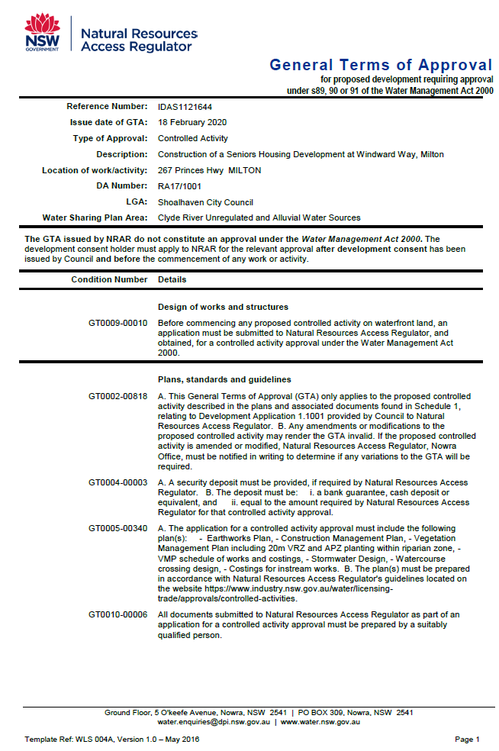

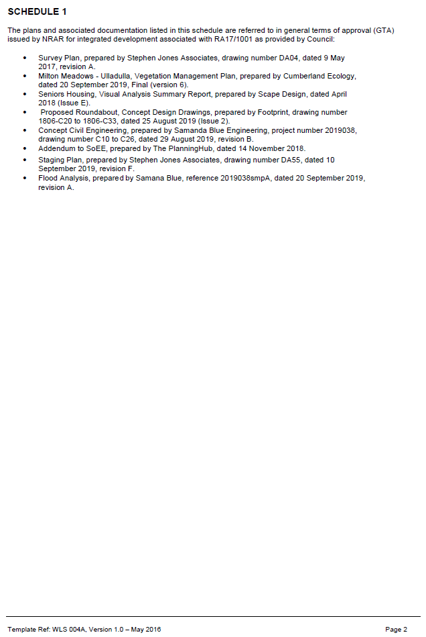

**Appendix C**

**NSW Rural Fire Service – General Terms of Approval**

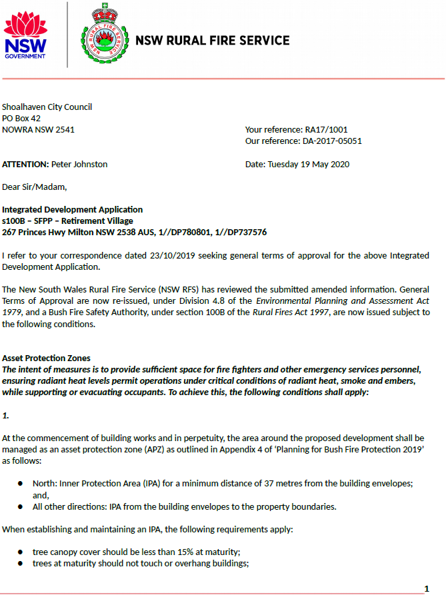

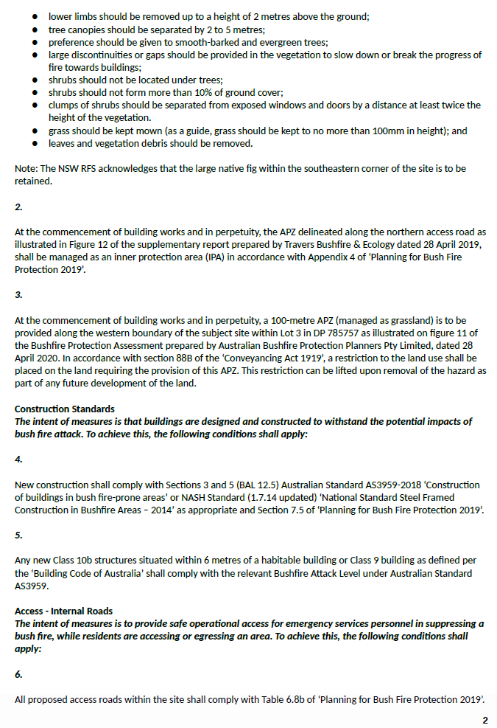

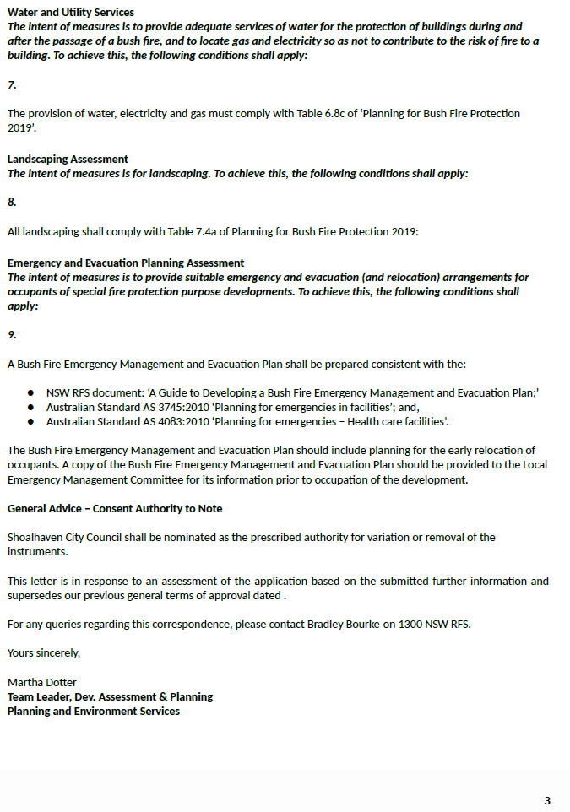

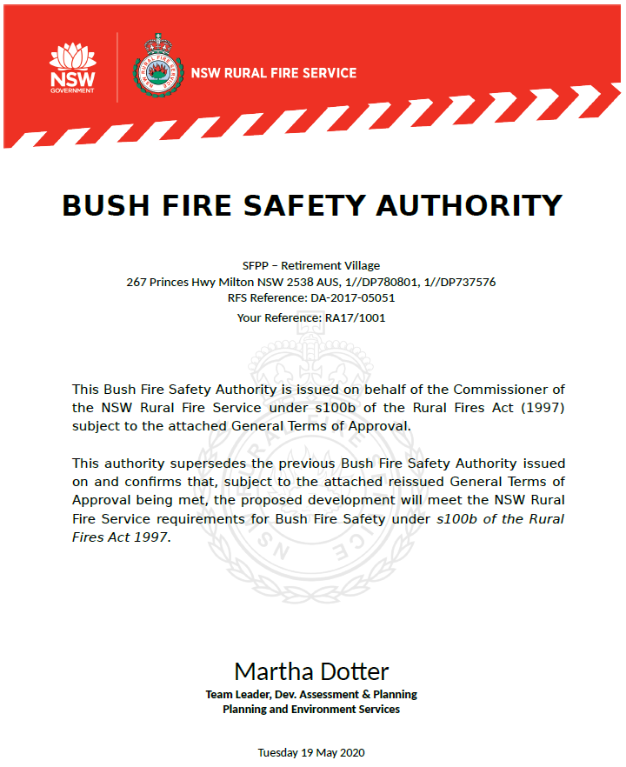

**Appendix D**

**Endeavour Energy Advisory Notes**

22/10/2019

Dear Sir or Madam

I refer to Council’s letter of 22 October 2019 regarding Regional Development RA17/1001 at 267 Princes Highway MILTON (Lot 1 DP 737576, Lot 1 DP 780801, Lot 0  DP U3 2224)  for ‘Revised description of works Phase 1 - Demolition of existing dwelling, pig pen and silo, construction of a roundabout and access from Princes Highway, 89 bed single storey Residential Care Facility, Clubhouse that comprises two levels incorporating the gym, all weather access swimming pool, recreational space, medical centre and a restaurant that can be accessed by both residents of the development and members of the public, ancillary services/facilities and 64 independent living units in duplex and triplex dwellings and associated works. Phase 2 - Construction of 63 independent living units in duplex and triplex dwellings and associated works. Phase 3 - Construction of 133 independent living units spread across 7 three storey residential flat buildings with basement parking, on-site detention pond on the northern boundary and associated works’. Submissions need to be made to Council by 12 November 2019.

Please find attached a copy of Endeavour Energy’s submission made to Council on 12 December 2018  regarding Regional Development RA17/1001 at 267 Princes Highway MILTON (Lot 1 DP 737576, Lot 1 DP 780801, Lot 0  DP U3 2224)  for ‘Demolition of existing pig pen and silo and phased construction of Seniors Housing comprising 89 bed single storey Residential Care Facility and associated parking; 130 independent living units in the form of single storey duplex and triplex dwellings; 133 independent living units within 7 separate 3 storey flat buildings with connected underground parking; 2 storey clubhouse with medical centre, gym, swimming pool, recreational space, restaurant and associated parking; 3 stormwater detention basins, ancillary services and civil infrastructure including new access road with direct connection to the Princes Highway’.  Notwithstanding the  revisions / modifications, the recommendations and comments previously provided remain valid.

Endeavour Energy’s further recommendations and comments are as follows:

* Network Capacity / Connection

Please find attached for the applicant’s reference an updated copy of Endeavour Energy’s Form FPJ6007 ‘Technical Review Request’.

The Accredited Services Provider (ASP) scheme is now administered by NSW Energy and details are available on their website via the following link or telephone 13 77 88:

<https://energy.nsw.gov.au/government-and-regulation/legislative-and-regulatory-requirements/asp-scheme-and-contestable-works>  .

* Urban Network Design

Endeavour Energy’s Company Policy 9.2.5 ‘Network Asset Design’, includes the following requirements for electricity connections to new urban subdivision / development:

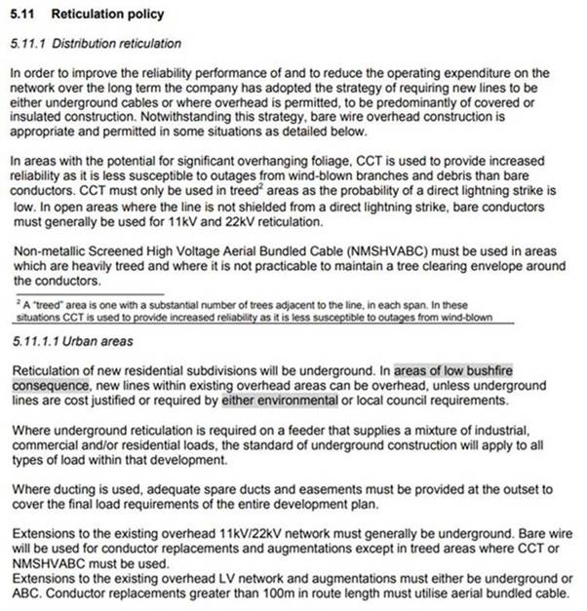

Subject to the foregoing Endeavour Energy has no objection to the Development Application.

Yours faithfully

Cornelis Duba

Development Application Specialist

Network Environment & Assessment

T:  9853 7896

E:  [cornelis.duba@endeavourenergy.com.au](mailto:cornelis.duba@endeavourenergy.com.au)

51 Huntingwood Drive, Huntingwood  NSW  2148

[**www.endeavourenergy.com.au**](http://www.endeavourenergy.com.au)



***12/12/2018***

Dear Sir or Madam

I refer to the Council’s letter of 28 November 2018 regarding Regional Development RA17/1001 at 267 Princes Highway MILTON (Lot 1 DP 737576, Lot 1 DP 780801, Lot 0  DP U3 2224)  for ‘Demolition of existing pig pen and silo and phased construction of Seniors Housing comprising 89 bed single storey Residential Care Facility and associated parking; 130 independent living units in the form of single storey duplex and triplex dwellings; 133 independent living units within 7 separate 3 storey flat buildings with connected underground parking; 2 storey clubhouse with medical centre, gym, swimming pool, recreational space, restaurant and associated parking; 3 stormwater detention basins, ancillary services and civil infrastructure including new access road with direct connection to the Princes Highway’. Submissions need to be made to Council by 19 December 2018.

As shown in the below site plans from Endeavour Energy’s G/Net master facility model (and the extract from Google Maps Street View) there are:

* No easements over the site benefitting Endeavour Energy (active easements are indicated by red hatching).
* Low voltage and 11,000 volt / 11 kV (constructed at 22,000 volt / 22 kV) high voltage overhead power lines (including pole mounted substation no. 72655 indicated by the symbol   ) traversing the site which are not held under easement.
* To the Princes Highway road verge / roadway low voltage and 11 kV high voltage overhead power lines.
* The Garrads Lane road frontage has  low voltage and 11 kV (constructed at 22 kV) high voltage overhead power lines (including pole mounted substation no. 26796) and low voltage underground cables to the opposite side of the road.
* The Warden Street road verge / roadway there are low voltage overhead power lines to part of the road frontage.
* The Windward Road road verge / roadway there are low voltage overhead power lines to part of the road frontage.

Please note the location, extent and type of any electricity infrastructure, boundaries etc. shown on the plan is indicative only.  Generally (depending on the scale and/or features selected), low voltage (normally not exceeding 1,000 volts) is indicated by blue lines and high voltage (normally exceeding 1,000 volts but for Endeavour Energy’s network not exceeding 132,000 volts / 132 kV) by red lines (these lines can appear as solid or dashed and where there are multiple lines / cables only the higher voltage may be shown). This plan only shows the Endeavour Energy network and does not show electricity infrastructure belonging to other authorities or customers owned electrical equipment beyond the customer connection point / point of supply to the property. This plan is not a ‘Dial Before You Dig’ plan under the provisions of Part 5E ‘Protection of underground electricity power lines’ of the *Electricity Supply Act 1995* (NSW).

In regards to the low voltage and 11 kV (constructed at 22 kV) high voltage overhead power lines traversing the site which are not held under easement, they are protected assets under the *Electricity Supply Act 1995* (NSW)  Section 53 ‘Protection of certain electricity works’. The owner or occupier of the land  cannot take any action by reason of the presence or operation of the electricity works in, on or over the land ie. they cannot remove the electricity infrastructure from the property. These protected assets are managed on the same basis as if an easement was in existence.

As shown in the following extract of Endeavour Energy’s Mains Design Instruction MDI 0044 ‘Easements and Property Tenure Rights’, Table 1 ‘Minimum easement widths’, the notional easement width required by for low voltage overhead power lines is 9 metres wide ie. 4.5 to both sides of the centre line of the poles / wires.

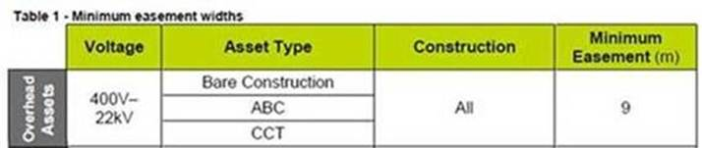

Alternatively,  as a minimum, any buildings, structures, etc. must comply with the minimum safe distances / clearances for voltages up to and including 132,000 volts (132kV) as specified in:

* Australian/New Zealand Standard AS/NZS 7000 – 2016: ‘Overhead line design’.
* ‘Service and Installation Rules of NSW’ which can accessed via the following link to the NSW Resources & Energy website:

<https://www.resourcesandenergy.nsw.gov.au/energy-supply-industry/pipelines-electricity-gas-networks/network-connections/rules> .

These distances must be maintained regardless of the Council’s allowable building setbacks etc. under its development controls.

As a guide please find attached a copy of Endeavour Energy Drawing ‘Overhead Lines Minimum Clearances Near Structures’.

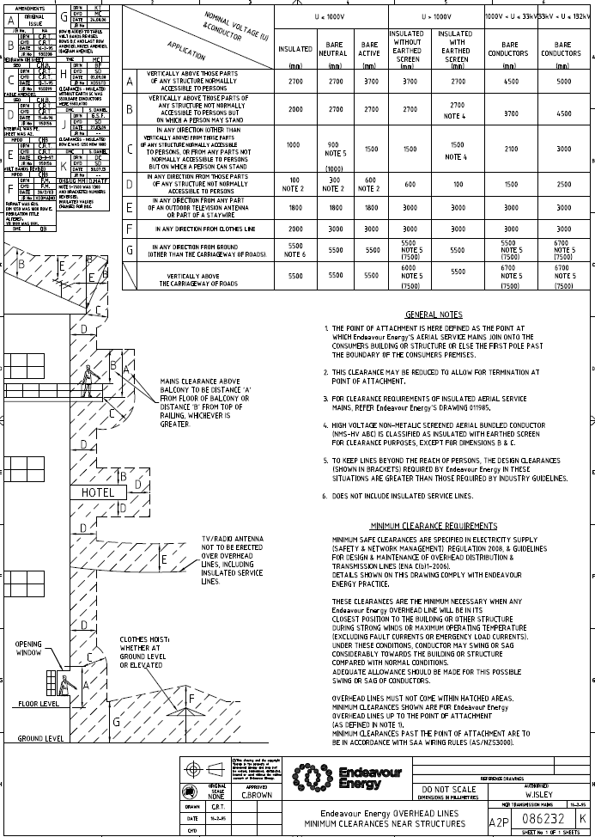

The following is a summary of the usual / main terms of Endeavour Energy’s electrical easements requiring that the land owner:

* Not install or permit to be installed any services or structures within the easement site.
* Not alter the surface level of the easement site.
* Not do or permit to be done anything that restricts access to the easement site without the prior written permission of Endeavour Energy and in accordance with such conditions as Endeavour Energy may reasonably impose.

Endeavour Energy’s preference is for no activities or encroachments to occur within its easement areas. Most activities are prohibited within the padmount substation easement area. If any proposed works (other than those approved / certified by Endeavour Energy’s Network Connections Branch as part of an enquiry / application for load) which encroach/affect Endeavour Energy’s easements or protected assets, contact must first be made with the Endeavour Energy’s Easements Officer, Jennie Saban, on mobile 0417484402 or alternately via email [Jennie.Saban@endeavourenergy.com.au](mailto:Jennie.Saban@endeavourenergy.com.au) or [Easements@endeavourenergy.com.au](mailto:Easements@endeavourenergy.com.au) .

Although the Electrical Servicing Report indicates that these electrical assets are likely to become redundant, in the interim the foregoing requirements are still applicable.

Subject to the foregoing and the following recommendations and comments Endeavour Energy has no objection to the Development Application.

* Network Capacity / Connection

Endeavour Energy has noted the following in the Revised Addendum Statement of Environmental Effects.

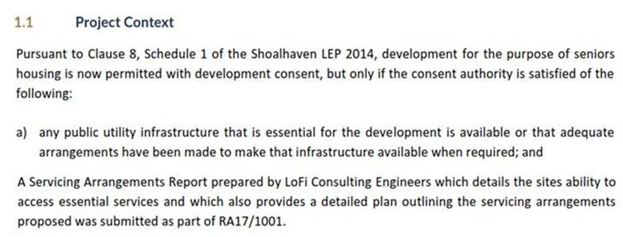

Endeavour Energy was provided with a copy of the Electrical Servicing Report prepared by Simplex Engineering dated 18 May 2017.

Endeavour Energy’s Asset Strategy & Planning Branch whilst not having undertaken a detailed analysis of the Electrical Servicing Report have provided the following advice:

*The report is now some 18 months old. Part 3 includes a copy of the Technical Review Request (TRR) to Endeavour Energy.  Asset Strategy & Planning have not received a TRR or application for connection of load for the site. There are other enquiries for new loads in the same area.*

*The proponent is proposing a significant load from ‘3 x 1,000kVA PM substations’, however there is limited capacity to the 11 kV feeders.*

*The closest feeder to the proposed development is 11 kV feeder ULK2 from Ulladulla Transmission  / Zone Substation located at North Street Ulladulla (Lot 32 DP 235607; Lot 33 DP 828219).*

*When a TRR or application for load is received, it will require a thorough analysis of Ulladulla Zone Substation’s 11 kV distribution network. This will determine any customer and/or Endeavour Energy upstream augmentation works required to accommodate the load.*

*The staged development, depending on the overall timing, should help with the delivery of any augmentation works required.*

In due course the applicant for the future proposed redevelopment of the site will need to submit an application for connection of load via Endeavour Energy’s Network Connections Branch to carry out the final load assessment and the method of supply will be determined. Depending on the outcome of the assessment, any required padmount or indoor / chamber substation will need to be located within the property (in a suitable and accessible location) and be protected (including any associated cabling) by an easement and associated restrictions benefiting and gifted to Endeavour Energy. Please refer to Endeavour Energy’s Mains Design Instruction MDI 0044 ‘Easements and Property Tenure Rights’. Further details are available by contacting Endeavour Energy’s Network Connections Branch via Head Office enquiries on telephone: 133 718 or (02) 9853 6666 from 8am - 5:30pm or on Endeavour Energy’s website under ‘Home > Residential and business > Connecting to our network’ via the following link:

<http://www.endeavourenergy.com.au/> .

Advice on the electricity infrastructure required to facilitate the proposed development (including asset relocations) can be obtained by submitting a Technical Review Request to Endeavour Energy’s Network Connections Branch, the form for which FPJ6007 is attached and further details (including the applicable charges) are available from Endeavour Energy’s website under ‘Our connection services’. The response to these enquiries is based upon a desktop review of corporate information systems, and as such does not involve the engagement of various internal stakeholders in order to develop a ‘Connection Offer’.  It does provide details of preliminary connection requirements which can be considered by the applicant prior to lodging a formal application for connection of load.

Alternatively the applicant should engage a Level 3 ASP approved to design distribution network assets, including underground or overhead. The ASP scheme is administered by NSW Planning & Environment and details are available on their website via the following link or telephone 13 77 88:

<https://www.energy.nsw.gov.au/energy-supply-industry/pipelines-electricity-gas-networks/network-connections/contestable-works> .

* Location of Electricity Easements / Prudent Avoidance

The incorporation of electricity easements into privately owned lots is generally problematic for both Endeavour Energy and the future landowners and requires additional easement management to ensure no uncontrolled activities / encroachments occur within the easement area. Accordingly Endeavour Energy’s recommendation is that whenever reasonably possible, easements be entirely incorporated into public reserves and not burden private lots (except where they are remnant lots or not subject to development).

Endeavour Energy’s preference is to have continuity of its easements  over the most direct and practicable route affecting the least number of lots as possible. Therefore it generally does not support the incorporation of easements into to multiple / privately owned lots. This is also in keeping with a policy of prudent avoidance by the siting of more sensitive uses away from any electricity infrastructure to minimise exposure to electric and magnetic fields (EMF), noise etc. associated with the 24/7/365 (all day, every day of the year) operation of the electricity network.

Please find attached a copy of Energy Networks Association’s  ‘Electric & Magnetic Fields – What We Know, January 2016’ which can also be accessed via the Energy networks Australia website at <https://www.energynetworks.com.au/electric-and-magnetic-fields>  and provides the following advice:

*Electric fields are strongest closest to their source, and their strength diminishes rapidly as we move away from the source.*

*The level of a magnetic field depends on the amount of the current (measured in amps), and decreases rapidly once we move away from the source.*

Exposure to electric and magnetic fields (EMF) may be encountered in specific situations such as near substations, underground cables, specialised electrical equipment, or at elevated locations near lines. However, as the strengths of EMFs decrease rapidly with distance from the source,  typical exposure associated with Endeavour Energy’s activities and assets given the required easement widths, safety clearances etc. and having a maximum voltage of  132,000 volt / 132 kV, will with the observance of these separation distances should not exceed the recommended public exposure limits.

* Bushfire

Endeavour Energy has noted from the Statement of Environmental Effects that the site is mapped as bushfire prone land. Although the Bushfire protection Assessment does not include any recommendations regarding the electricity services to the site,  NSW Rural Fire Service ‘Planning for Bush Fire Protection 2006’ provides the following advice:

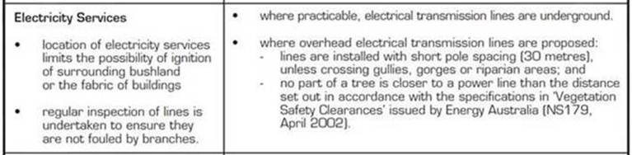

The following is an extract of Endeavour Energy’s Company Policy 9.1.1 Bushfire Risk Management:

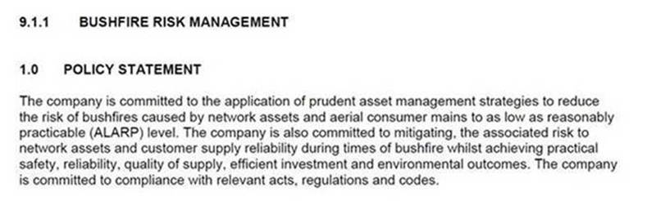

Accordingly the network required to service the proposed development must be fit for purpose and meet the technical specifications, design, construction and commissioning standards based on Endeavour Energy’s risk assessment associated with the implementation and use of the network connection / infrastructure for a bushfire prone site. In assessing bushfire risk, Endeavour Energy has traditionally focused on the likelihood of its network starting a bushfire, which is a function of the condition of the network. Risk control has focused on reducing the likelihood of fire ignition by implementing good design and maintenance practices. However safety risks associated with the loss of electricity supply are also considered.

* Flooding and Drainage

Distribution substation should not be subject to flood inundation ie. the padmount substation cubicles are weather proof not flood proof. Section 7 ‘Substation and switching stations’ of Endeavour Energy’s Mains Construction Instruction MCI 0006 ‘Underground distribution construction standards manual’ provides the following details of the requirements for flooding in new padmount substation locations.

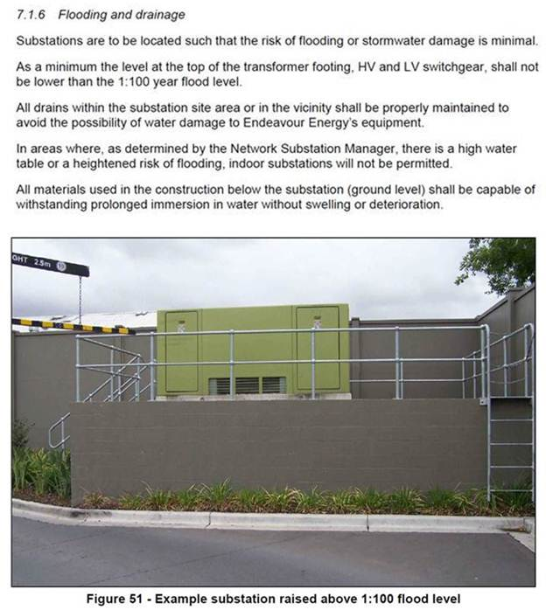

* Earthing

The construction of any building or structure (including fencing, signage, flag poles, hoardings etc.) whether temporary or permanent that is connected to or in close proximity to Endeavour Energy’s electrical network is required to comply with Australian/New Zealand Standard AS/NZS 3000:2018 ‘Electrical installations’ as updated from time to time. This Standard sets out requirements for the design, construction and verification of electrical installations, including ensuring there is adequate connection to the earth. Inadequate connection to the earth to allow a leaking/fault current to flow into the grounding system and be properly dissipated places persons, equipment connected to the network and the electricity network itself at risk from electric shock, fire and physical injury.

* Network Access

It is imperative that the access to the existing electrical infrastructure on and in proximity of the site be maintained at all times. To ensure that supply electricity is available to the community, access to the electricity infrastructure may be required at any time. Restricted access to electricity infrastructure by maintenance workers causes delays in power restoration and may have severe consequences in the event of an emergency.

* Vegetation Management

The planting of large trees in the vicinity of electricity infrastructure is not supported by Endeavour Energy. Suitable planting needs to be undertaken in proximity of electricity infrastructure. Only low growing shrubs not exceeding 3.0 metres in height, ground covers and smaller shrubs, with non-invasive root systems are the best plants to use. Larger trees should be planted well away from electricity infrastructure (at least the same distance from overhead power lines as their potential full grown height) and even with underground cables, be installed with a root barrier around the root ball of the plant. Landscaping that interferes with electricity infrastructure may become a potential safety risk, cause of bush fire, restrict access or result in the interruption of supply.  Such landscaping may be subject to Endeavour Energy’s Vegetation Management program and/or the provisions of the *Electricity Supply Act 1995* (NSW) Section 48 ‘Interference with electricity works by trees’ by which under certain circumstances the cost of carrying out such work may be recovered.

In regards to the padmount substation/s required to facilitate the further development of the site, please find attached for the applicant’s reference a copy Endeavour Energy’s ‘Guide to Fencing, Retaining Walls and Maintenance Around Padmount Substations’.

* Dial Before You Dig

Before commencing any underground activity the applicant is required to obtain advice from the ***Dial Before You Dig* 1100** service in accordance with the requirements of the *Electricity Supply Act 1995* (NSW) and associated Regulations. This should be obtained by the applicant not only to identify the location of any underground electrical and other utility infrastructure across the site, but also to identify them as a hazard and to properly assess the risk.

* Demolition

Demolition work is to be carried out in accordance with Australian Standard AS 2601—2001: ‘The demolition of structures’ as updated from time to time. All electric cables or apparatus which are liable to be a source of danger, other than a cable or apparatus used for the demolition works shall be disconnected ie. the existing customer service lines will need to be isolated and/or removed during demolition. Appropriate care must be taken to not otherwise interfere with any electrical infrastructure on or in the vicinity of the site eg. streetlight columns, power poles, overhead power lines and underground cables etc.

* Public Safety

Workers involved in work near electricity infrastructure run the risk of receiving an electric shock and causing substantial damage to plant and equipment. I have attached Endeavour Energy’s public safety training resources, which were developed to help general public / workers to understand why you may be at risk and what you can do to work safely. The public safety training resources are also available via Endeavour Energy’s website via the following link:

<http://www.endeavourenergy.com.au/wps/wcm/connect/ee/nsw/nsw+homepage/communitynav/safety/safety+brochures> .

If the applicant has any concerns over the proposed works in proximity of the Endeavour Energy’s electricity infrastructure, as part of a public safety initiative Endeavour Energy has set up an email account that is accessible by a range of multiple stakeholders across the company in order to provide more effective lines of communication with the general public who may be undertaking construction activities in proximity of electricity infrastructure such as builders, construction industry workers etc. The email address is  [Construction.Works@endeavourenergy.com.au](mailto:Construction.Works@endeavourenergy.com.au) .

* Emergency Contact

In case of an emergency relating to Endeavour Energy’s electrical network, the applicant should note the Emergencies Telephone is 131 003 which can be contacted 24 hours/7 days.

I appreciate that not all the foregoing issues may be immediately relevant or significant to the Regional Development. However, Endeavour Energy’s preference is to alert proponents / applicants of the potential matters that may arise should  development within closer proximity of the existing and/or proposed electricity infrastructure required to facilitate the proposed development on or in the vicinity of the site occur.

Could you please pass on a copy of this submission and the attached resources to the applicant? Should you wish to discuss this matter, or have any questions, please do not hesitate to contact me or the contacts identified above in relation to the various matters.  Due to the high number of development application  / planning proposal notifications submitted to Endeavour Energy, to ensure a response contact by email to [property.development@endeavourenergy.com.au](mailto:property.development@endeavourenergy.com.au)  is preferred.

Yours faithfully

Cornelis Duba

Development Application Specialist

Network Environment & Assessment

T:  9853 7896

E:  [cornelis.duba@endeavourenergy.com.au](mailto:cornelis.duba@endeavourenergy.com.au)

51 Huntingwood Drive, Huntingwood  NSW  2148

[**www.endeavourenergy.com.au**](http://www.endeavourenergy.com.au)



